1

Unit 1-2-3
+*
REVIEW

PRONOUNCIATION

Find the word which has a different sound in the part underlined.
1. A. aunt B. ball C. call D. chalk
2. A. houses B. toothbrushes C. stores D. glasses
3. A. oven B. brother C. stove D. roses
4. A. hands B. legs C. lips D. ears
5. A. Monday B. another C. month D. judo

B.
VOCABULARY and GRAMMMAR

Ex1. Write four more words for each category.
0. Personality shy friendly open reliable kind selfish
1. Hair style: short curly ………. ………. ………. ……….
2. Body build: fat well-built ………. ………. ………. ……….
3. Hair color: blonde black ………. ………. ………. ……….
4. Body part: neck nose ………. ………. ………. ……….
5. House room: bedroom kitchen ………. ………. ………. ……….
Ex 2. Complete the sentences with the present simple or present continuous form.
1. We (visit) ………………. our grandparents now.
2. They (not go) ………………. to work on Saturdays and Sundays.
3. Mr. Ninh (not work) ………………in the office tomorrow.
4. ………………. Mary (have) …………….. short hair?
5. I (meet) ………………. my uncle and aunt every day.
6. ………………. you (have) ………………. dinner with Mr.Bean tonight?
7. Bob (not like) ………………. to listen to rock music.
8. Hoang (live) ………………. in a small house in the centre of the village.
9. The team (play) ………………. football on Saturdays.
10. Ms Huong (teach) ………………. the class maths now.

Ex 3. Choose the best option (A, B, c or D) to complete these sentences.
1. John ………………. in a house in the countryside.
A. live B. lives C. living D. to live
2. We might have smart phones ………………. the Internet.
A. surf B. surfing C. to surf D. surfed
3. Robot will help us do the housework such as cleaning the floor, ……….meals and soon.
A. cooking B. to cook C. go D. going
4. If we ………………. waste paper, we will save a lot of trees.
A. repeat B. recycle C. review D. remark
5. If we plant more trees in the school yard, the school will be a …………. place.
A. darker B. dirtier C. greener D. more polluted
6. ……………….your house have an attic? - ………………. it does.
A. Do/ Yes B. Do/No C. Does/Yes D. Does/No
7. Where are you, Hai? - I’m downstairs. I ………………… to music.
A. listen B. to listen C. am listening D. listening
8. My close friend is ready ………………. things with her classmates.
A. share B. to share C. shares D. sharing
9. This Saturday, we to the Art Museum.
A. go B. going C. is going D. are going
10. My best friend, Hanh, is ………………. She talks all the time.
A. talkative B. kind C. confident D. creative
11. How often do you watch TV? - ……………….?
A. Twice B. One a week C. Five days D. Every day
12. Maggie was born under the ……………. of Virgo, she is very careful and hard-working.
A. story B. sight C. sign D. signal
13. ………………. does Lam go to school? - By school bus.
A. How B. Why C. What D. By what
14. What does your cousin Anh look like?
- He ………………. very tall, and he ………………. big eyes with a pair of glasses.
A. isn’t-have B. is-have C. isn’t-has D. don’t-has
15. Jane’s ………………. colors are red, white and gold.
A. love B. lovely C. likes D. favorite
Ex 4. Find a mistake and correct it.
1. The cat is among the lamp and the bed.
A B C D
2. There are a cupboard, a dishwasher and a table in the kitchen
A B C D
3. Is there a television front of the microwave?
A B C D
4. There are two bookshelf in my sister’s bedroom.
A B C D
5. I can see that there is a vase behind of the light.
A B C D
Ex 5. Supply the correct form of the word.
1. My neighbor has vast ……………. of past events. (know)
2. The weatherman says there is a strong ……………. of rain today. (possible)
3. Athens is ……………. for its ancient buildings. (fame)
4. His picture is very ……………. (create)
5. The news isn’t very…………… (cheer)
READING

Ex 1. Read the conversation then fill in the missing words to complete the sentences.
Mi: Mum, are you home?
Mum: Yes, honey. I’m in the kitchen. I’ve bought these new dishes.
Mi: They’re beautiful, Mum. Where did you buy them?
Mum: In the department store near our house.
There are a lot of interesting things for the home there.
Mi: We need some pictures for the living room, Mum.
Do they have pictures in the store?
Mum: No, they don’t. But there are some ceiling lights.
We are buying two for the new apartment this week.
Mi: We also need two new vases, Mum.
Mum: That’s true. Let’s go to the store this weekend.

1. My’s Mum is in the ……………………………………………
2.The ……………………………………………… are beautiful.
3. The department store doesn’t have any ………………………
4. Her Mum is buying two ………………………………… for their new apartment.
5. They will ……………………………… to the department store this weekend.

Ex 2. Complete the sentences.
1. Mi: ………………. you turn on the lights?
Duy: OK. I’ll do it right away.
2. James: Would you like to come to my party tomorrow evening?
Phuc: I would ………………. to, but I’m visiting my grandma.
3. Mi: Oh, dear. I forgot my pencil sharpener.
Vy: That’s OK. You …………………………….
4. Phuc: Would you like to have a barbecue with US on Sunday?
Nhung:………………………….. I’m not doing anything on Sunday.
5. Huy: What are you going to do this weekend?
Huong: This weekend I ……………to visit my grandparents in Ninh Binh city.

Ex 3. Read the email, choose the best answer A, B, c or D and write.
From: an@fastmail.com
To: nick@fastmail.com
Subject: My best friend
Hi Nick,
It’s great to hear from you. I want to tell you about my best friend.
My grandma is my best friend. She’s 68 years old. She lives with our family. She was a Maths teacher at a secondary school. She likes getting up early and watering the flowers in our garden, she usually helps me with my homework. In the evening, she tells me interesting stories. She also listens to me when I’m sad. I love my grandma very much.
What about you? Who’s your best friend?
Please write to me soon.
Bye bye,
An

1. The e-mail is about ……………………………………
A. An’s best friend at school B. An’s grandma
C. An’s math teacher D. An’s mom
2. …………………………………… is his grandma’s hobby.
A. helping An do his homework B. watering flowers
C. telling stories D. listen to music
3. An usually listens to his grandma’s stories in the …………………………………
A. morning B. afternoon C. evening D. at noon
4. An likes his grandma best because ……………………………………
A. she lives with his family. B. she gets up early every morning,
C. she always listens to him when he’s sad. D. she is a Maths teacher.

LISTENING

Ex 1. You are going to hear Linh describing his new house.
Listen and decide if the statements below are true (T) or false (F).
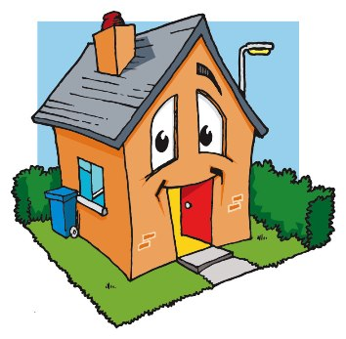

1. Linh’s house is small.
2. Her house has more than four rooms.
3. Her room is far from the living room.
4. Linh’s sister’s room is between Linh’s room and her parents’ room.
5. Linh’s room is next to her parents’ room.
Ex 2. Listen again and complete the sentences below.
1. In Linh’s room, the desk is near the ……………................
2. In Linh’s room, the computer is on the ……………................
3. Linh’s parents don’t have a ……………................ in their room.
SPEAKING

Ex 1. Look at the picture below. Describe the things in the room.
You should base on some suggestions below:
- What furniture is there in the room from the left/right to the right/left?
- How does the furniture look like?
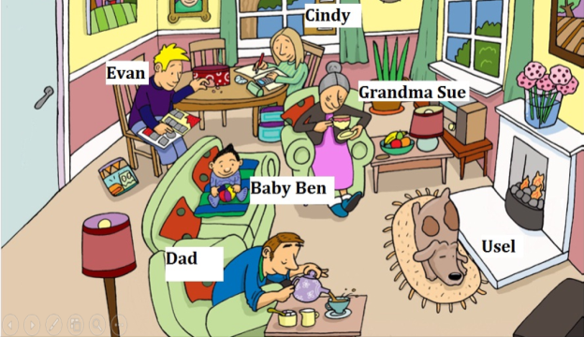
Ex 2. Look at the picture again. Now describe what people in the room are doing.
You should use the Present Continuous tense.

WRITING

Ex 1. Reorder the following words to make meaningful sentences.
1. a/ classroom/ map/ and/ has/ my/ a/ projector/.

2. Sue/ going/ school/ is/ to/ by / tomorrow/ bus.

3. the/ in/ bookshelf/ room/ is/ my/ next/ the/ to/ window.

4. difficult/ friends are talking/ my/ about/ a/ exercise/ now.

5. Lien/ house/ is/ live/ my/ and/ classmate/ near/ I/ her/ too.

Ex 2. Rewrite the following sentences based on the given words.
1. Mary’s hair is short and her face is round.
→ Mary has
2. My house is next to a big super-market.
→ There is
3. There are some trees in front of my school.
→ Some trees are
4. My school is far from my house.
→ My school is not
5. Dave is cleaning the floor. His brother is not doing anything.
→ …………………………………………, but

ĐÁP ÁN CHI TIẾT

REVIEW
+*
Unit 123
1

PHONETICS

1. A 2. C 3. B 4. C 5. D
VOCABULARY AND GRAMMAR
Ex I.
1. wavy, long, straight, shoulder-length...
2.thin, slim, obese, medium height...
3.brown, black, red...
4.hands, head, mouth, chest...
5.living room, restroom, attic, bathroom...
Ex II.
1. are visiting 2. don’t go
3. isn’t working 4. Does....have
5. met 6. do ... have
7. doesn’t like 8. lives
9. plays 10. is teaching
Ex III.
1.B 2. C 3.A 4. B 5. C
6. C 7. C 8. B 9. D 10. A
11. D 12. C 13. A 14. C 15. D
Ex IV.
1. B (between) 2. A (is)
3. C (in front) 4. B (bookshelves)
5. D (x)
Ex V.
1. knowledge 2. possibility
3. famous 4. creative
5. cheery/ cheerful
READING
Ex I.
1. kitchen 2. new dishes
3. pictures 4. ceiling lights 5. go
Ex II.
1. can
2.like/ love
3.can use mine
4.It’s amazing/ great/ good idea
5. am going
Ex III.
1. B 2. B 3. C 4. C
LISTENING
ExI.
1. F 2. T 3. F 4. T 5. F

Ex II.
1.window 2. desk 3. TV
Listening transcript:
My family has a big house. There are five rooms in my house. My room is next to the living room. In my room I have a desk near the window. My computer is on the desk. I have a big bookshelf and many pictures of my idol. My sister’s room is to the left of my room and to the right of my parents’ room. My parents’ room is large, but they don’t have a TV in their room because my parents don’t like watching TV.
WRITING
I.
1. My classroom has a projector and a map.
2. Sue is going to school by bus tomorrow.
3. In my room, the bookshelf is next to the window.
4. My friends are talking about a difficult lesson now.
5. Lien is my classmate, and I live near her house, too.
II.
1. Mary has short hair and a round face.
2. There is a super-market next to my house.
3. Some trees are in front of my school.
4. My school is not near my house.
5. Dave is cleaning the floor, but his brother is not doing anything.

