PHÒNG GD VÀ ĐT THẠCH THẤT TRƯỜNG TIỂU HỌC HƯƠNG NGẢI
Họ và tên: ………………………… Lớp:..…………

BÀI KIỂM TRA ĐỊNH KÌ CUỐI NĂM MÔN TIẾNG ANH - LỚP 3
NĂM HỌC 2019 – 2020
Thời gian làm bài: 40 phút

Marks: | Listening |  |  |  |  | Reading and writing |  |  |  | Speakin g | Total
Marks: | Q. 1 | Q. 2 | Q. 3 | Q. 4 | Q. 5 | Q. 6 | Q. 7 | Q. 8 | Q. 9 | Q.10

PART 1. LISTENING (20 minutes)

Question 1. Listen and number (1 pt)


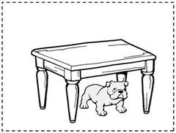

B.
A..



C. D.

Question 2. Listen and write T (True) or F (False) (1pt)

- There is a living room

- There are two books on the table.

- I like trucks.

- I’ve got four cats.

1

Question 3. Listen and draw the line. (1 pt)
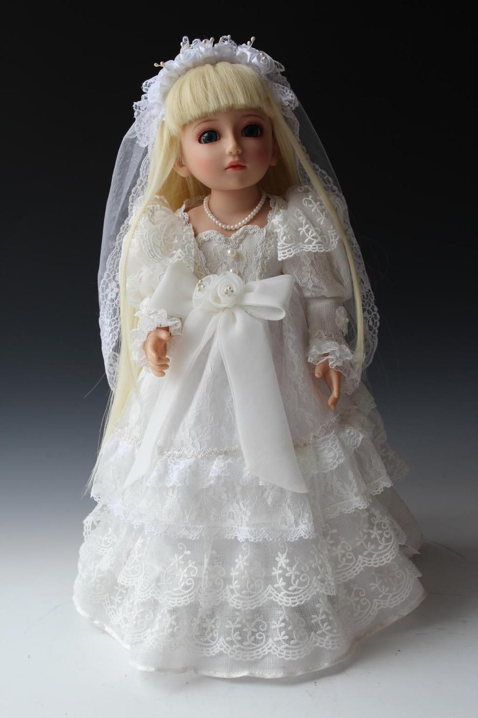




1
2
3
4

Question 4. Listen and tick. (1 pt)
- Laura: What is the weather like ?
Jimmy: ………………………


A.


B.
C.
- Lilly: What are they doing ?
John: ………………………..
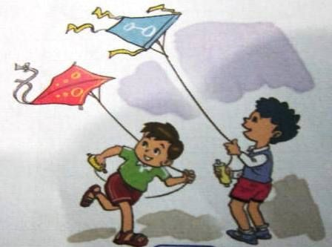
. 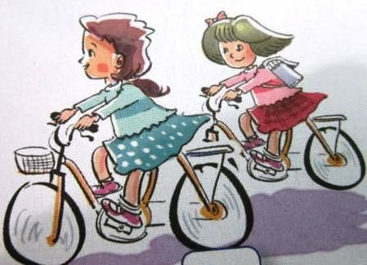 
  - B. C.

- Mary: What pets do you have?



Peter :……………………

  - B. C.

2
- Jane: What toys do you like?
Tom: ……………………..

A.  B. 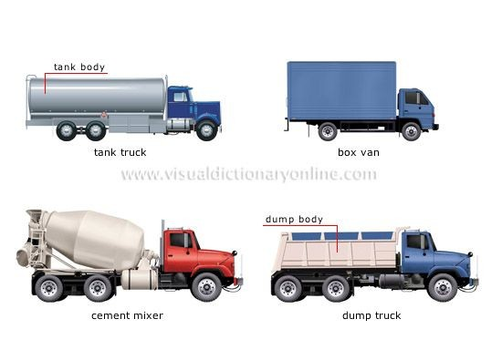 C. 

Question 5. Listen and complete. (1pt)
My name is Quan.Today my family (1) at home.We are in the living room. My father is (2) TV. My mother is (3) the piano. My brother is
- to music and I am singing.

PART II. READING AND WRITING (15 minutes)

Question 6. Look and read. Put a tick ( ) or cross (X) in the box. (1pt).

  - They are reading book .


  - She is cleaning the floor.


  - It is windy

  - This is my house .

3


Question 7. Look and read. Write Yes or No (1pt).

- This is a fish.


- It’s windy today.


- He’s playing badminton.


- I’ve got three ships

Question 8. Look at the pictures. Look at the letters. Write the words (1 pt)


  - usnyn




  - tebla
_ _ _ _ _ _ _

_ _ _ _ _ _ _

3. parotr _ _ _ _ _ _ _

4. ingsing _ _ _ _ _ _ _

Question 9: Choose the word from the box and write as example (1 point)

this | friend | name | is | Nam

4

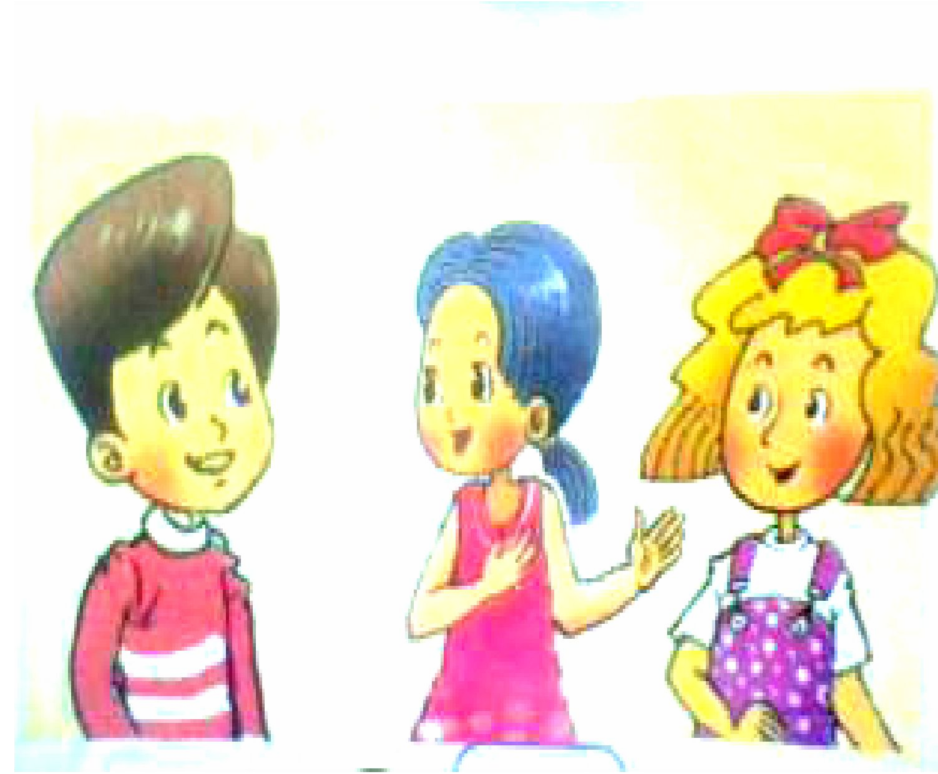
Nam: Hi. My name’s Nam. What is your (0) name ? Mai: Hello, (1) . My name’s Mai.
Nam: Who’s (2) ?
Mai: She is Linda. She is my (3) . Nam: How old (4) she?
Mai: She is nine. Linda: Hello, Nam.

PART III SPEAKING (1pt) (5’)

Question 10.
1. Listen and repeat 2. Point, ask and answer
3. Listen and comment 4. Interview

The End

Lời bài nghe và đáp án

Question 1. Listen and number. (1 pt)
- A: Where’s the dog ? B: It’s under the table.
- A: What are you doing ? B: I am listening to music.
- A: What’s the weather like? B: It’s rainy.
- A: Do you have a goldfish? B: Yes, I do.

Question 2. Listen and write T (True) or F (False) (1pt).
  - There is a living room

  - There are five books on the table.

5
  - I like robots.

  - I’ve got four cats.

Question 3. Listen and draw the line. (1 pt)
- A: Do you like planes?
- B: No, I don’t.
2. I like ships.

Question 4. Listen and tick. (1 pt)
- Laura: What is the weather like ? Jimmy : It’s windy.
- Lilly: What are they doing ? John: They’re flying kites.
- Mary: What pets do you have? Peter : I have two dogs.
- Jane: What toys do you like? Tom: I like yo-yos.

Question 5. Listen and complete. (1pt)
My name is Quan.Today my family (1) _is at home.We are in the living room. My father is (2) watching TV. My mother is (3)_playing the piano. My brother is (4) listening to music and I am singing.

PART II. READING AND WRITING (15 minutes)

Question 6. Look and read. Put a tick ( ) or cross (X) in the box. (1pt).
1.  2. X 3.  4.

Question 7. Look and read. Write Yes or No (1pt)
1. Yes 2. Yes 3. No 4. Yes

Question 8. Look at the pictures. Look at the letters. Write the words. (1 pt)
1. Sunny 2. Table 3. Parrot 4. Singing

Question 9: Choose the word from the box and write as example (1 point)
- Nam 2. this 3. friend 4. is

6
Trường TH Phạm Văn Đồng ĐỀ KIỂM TRA CUỐI HỌC KỲ II
Họ và tên:....................................... MÔN TIẾNG ANH LỚP 3
Lớp 3.......... Thời gian: 40 phút - Năm học 2014 – 2015

Marks: | Q.1 | Q.2 | Q.3 | Q.4 | Q.5 | Q.6 | Q.7 | Q.8 | Total:

PART 1: LISTENING ( 20 minutes)

Question 1. Listen and number. (1 pt)





A B C D

Question 2. Listen and draw the line. There is an example. (1 pt)
0
1
2
3
4




Question 3. Listen and tick. (2 pt)
1.  A
B



- A B



- A
B

4.
17
11
A B

Question 4. Listen and write (1pt)
- There are two posters __ _the wall.
- The balls are _the bed.
- I have a___ .
3. My sister has two__ _.

PART II: READING AND WRITING (20 minutes)

Question 5. Read and circle (1pt).

- There (is / are) one wardrobe in the bedroom.
- I have four (robot/ robots)
- Nam (have/ has) two balls.
- He is (playing/ listening) to music.
- How many (toy/ toys) do you have?

Question 6. Choose a word from the box and write it next to numbers from 1-4. (1pt)
Linda kitchen home cleaning watching

Linda’s family is at (1) home now. Her parents are in the (2) _. They are cooking a big meal. Her brother is (3)___ _TV in his room. (4)__ _is in the living room. She is (5) the floor.

Question 7. Look at the pictures. Look at the letters. Write the words . (1 pt)
1.  rac ->…………… 2.  lold-> ……………



3 birbat ->…………… 4. tca ->……………

Question 8: Reoder the words to make sentences. (1pt)
Example: This/ living room/ is/ a.. This is a livingroom.
1. There/ four/ are/ doors ............................................................................
2. I/ a/ robot/ have........................................................................................
3. He/ brothers/ two/ has.................................................................... .................
4. She/ the/ playing/ is/ piano..............................................................................

ĐÁP ÁN

Question 1: (1.đ) Mỗi câu đúng chấm 0,25 đ
- There is a garden in front of the house. 3. There is a kitchen.
- A: This is my bedroom. 4. The bathroom is big. B: Oh, it’s nice
Đáp án: A. 2 B. 1 C. 4 D. 3

Question 2: (1.đ) Mỗi câu đúng chấm 0.25 đ
- I have a parrot.
- Do you have a teddy bear? - > Yes, I do
- My brother has a goldfish.
- Nam has a plane.
- What toys do you like? -> I like ships.

Question 3: (2.đ) Mỗi câu đúng chấm 0.5 đ
- A. What are they doing? -> They are playing kites.
- B. What’s the weather like? -> It’s sunny.
- A. They are playing hide and seek.
- A. How old is your sister? -> She’s eleven.

Question 4:(1.đ) Mỗi câu đúng chấm 0.25 đ
1. There are two posters on the wall. 2. The balls are under the bed.
- I have a dog. 4. My sister has two rabbits Question 5: (1.đ) Mỗi câu đúng chấm 0.25đ
  - is 2. robots 3. has 4. listening 5. toys

Question 6: (1.đ) Mỗi câu đúng chấm 0.25đ
1. home 2. kitchen 3. watching 4. Linda 5. cleaning

Question 7: (1.đ) Mỗi câu đúng chấm 0.25đ
1. car 2. doll 3. rabbit 4. cat

Question 8: (1.đ) Mỗi câu đúng chấm 0.25đ
- There are four doors.
- I have a robot.
- He has two brothers.
- She is playing the piano.

Trường Tiểu học B Yên Đồng | BÀI KIỂM TRA ĐỊNH KỲ CUỐI NĂM
 | Năm học : 2019 - 2020
Họ và tên :…………….……………….. | Môn : TIẾNG ANH - LỚP 3
Lớp: 3. .……. | Thời gian làm bài 40 phút

Bài 1. Hãy quan sát kỹ bức tranh rồi điền chữ cái chỉ bức tranh đó (5 điểm).

A. Rubber B. Ship C. House

D. Parrot E. Dog F. Plane
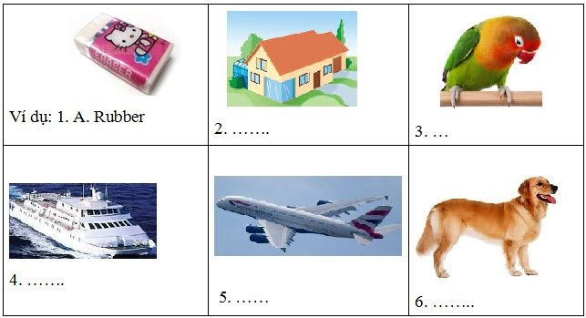

Bài 2. Đọc và hoàn thành các câu với những từ trong khung (2 điểm)

like trucks How ten cats

I have many toys. I have five (1) trucks, three planes, and (2) ………. yo-yos. My friend Hoa has some pets. She has two dogs and three (3) …………… . What about you? What toys do you (4) ……… ?
- ...…… many pets do you have?

Bài 3. Đọc và nối (2 điểm)
1. What are you doing? | A. It’s in north Viet Nam.
2. What’s the weather like? | B. I have five.
3. Where’s Sa Pa? | C. I’m watching TV.
4. How many trucks do you have? | D. It’s sunny.

Bài 4. Hãy sắp xếp các từ theo đúng thứ tự để tạo thành câu có nghĩa (1 điểm).

- have / Do / pets / you / any /?

------------------------------------------------------------------

- playing / piano / am / I / the /.

-----------------------------------------------------------------

- far / Ha Long Bay / from / is / Ha Noi /.

-----------------------------------------------------------------

- you / toys / Do / like / ?

-----------------------------------------------------------------

ĐÁP ÁN
Bài 1: 5 điểm.

Chọn đúng mỗi đáp án cho 1 điểm / câu.

2. C 3. D 4. B 5. F 6. E

Bài 2: 2 điểm.

Điền đúng mỗi từ cho 0,5 điểm.

- trucks 2. ten 3. cats 4. like 5. How

Bài 3: 2 điểm.

Chọn đúng mỗi đáp án cho 0,5 điểm / câu.

1. C 2. D 3. A 4. B

Bài 4: 1 điểm.

  - Viết đúng thứ tự và chỉnh tả mỗi câu cho 0,25 điểm / câu.
  - Viết sai chính tả 1, 2 lỗi trừ 50% số điểm mỗi câu.
  - Viết sai chính tả từ 3 trở lên không cho điểm.

- Do you have any pets?.

- I am playing the piano.
- Ha Long Bay is far from Ha Noi.

- Do you like toys?

TRƯỜNG TH CÔN MINH BÀI KIỂM TRA CUỐI HỌC KỲ II

Họ và tên: ………………………………………. Môn: Tiếng Anh
Lớp: 3 Thời gian: 35 phút (không kể giao đề)
Điểm
Nhận xét của giáo viên

A. PHẦN TRẮC NGHIỆM: (5 điểm)
- Circle the odd one out ( Khoanh tròn 1 từ khác với những từ còn lại ) (2,5đ)

1. A. Sunny | B. Library | C. Windy | D. Cloudy
2. A. Six | B. Seven | C. School | D. Ten
3. A. Cat | B. Fish | C. Bird | D. Pencil
4. A. Bedroom | B. Chair | C. Bathroom | D. Kitchen
5. A. Book | B. Pen | C. Robot | D. Ruler
- Circle the correct answers A , B or C. (Khoanh vào đáp án đúng A, B hoặc C) (2,5đ)
1. ............... I’m Linda.
  - Hello B. Goodbye C. What
- How old ............. she ? - She is ten years old.
  - am B. is C. are
- .............. many dogs do you have?
  - What B. How C. Where
- There is a …….….. in the bedroom.
  - bed B. clouds C. dogs
- How’s the weather today? - It’s …….……
  - ship B. ball C. sunny

PHẦN TỰ LUẬN: (5 điểm)
- Match the questions and answers. (Nối câu hỏi ở cột A với câu trả lời ở cột B) (2,5đ)

A | B | ANSWERS
1. How’s the weather today? | A. That’s my father. | 1.
2. How many cats are there? | B. I’m nine. | 2.
3. How old are you? | C. His name’s Tam. | 3.
4. Who’s that? | D. It’s rainy. | 4.
5. What’s his name? | E. There are five. | 5.

- Reorder the words to the complete sentence (Sắp xếp các từ sau thành câu đúng) 2,5đ
- windy / It’s / today. //

………………………………….……………………………………………………..

- nine / I / years / am / old. //

………………………………………………………………………………………..

- is / school / This / my. //

………………………………………………………………………………………..

- to / you / Nice / meet //

…………………………………..…………………………………………………….

- your / What / is / name /? //

………………………………… …………………………………………………….

THE END

TRƯỜNG TH CÔN MINH ĐÁP ÁN BÀI KIỂM TRA CUỐI HỌC KỲ II
*** ******
Môn: Tiếng Anh - Lớp 5
I. PHẦN TRẮC NGHIỆM: (5pts)
- Circle the odd one out: Khoanh tròn từ khác loại (2,5pts)

Mỗi câu đúng 0,5 điểm

1. B | 2.C | 3. D | 4. B | 5. C
- Circle the correct answers A , B or C. (Khoanh vào đáp án đúng A, B hoặc C) (2,5đ)

Mỗi câu đúng 0,5 điểm
1. A 2. B 3. B 4. A 5. C

B. PHẦN TỰ LUẬN: (5 điểm)
- Match the questions and answers. (Nối câu hỏi ở cột A với câu trả lời ở cột B) (2,5đ)

Mỗi câu đúng 0,5 điểm

A | B | ANSWERS
1. How’s the weather today? | A. That’s my father. | 1. D
2. How many cats are there? | B. I’m nine. | 2. E
3. How old are you? | C. His name’s Tam. | 3. B
4. Who’s that? | D. It’s rainy. | 4. A
5. What’s his name? | E. There are five. | 5. C
- Reorder the words to the complete sentence (Sắp xếp các từ sau thành câu đúng) 2,5đ Mỗi câu đúng 0,5 điểm
- It’s windy today.

- I am nine years old.

- This is my school.

- Nice to meet you!

- What is your name?

THE END

