ĐỀ THI HỌC KÌ 2 LỚP 1 MÔN TIẾNG ANH
I. Look and write:

up  down | juice  apples | a boy  a girl |  | a book  a car
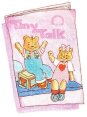 | Ex: a book |  | 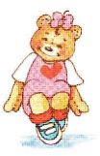 |  | 1.____________
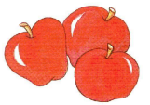 | 2.__________ |  | 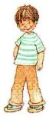 |  | 3.___________
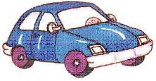 | 4.___________ |  | 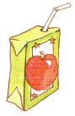 |  | 5.____________
 | 6._____________ |  | 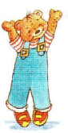 |  | 7._____________
II. Look at the picture and complete the word:
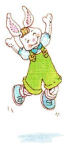 | Ex: jump | 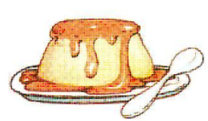 | 1. pu_ding
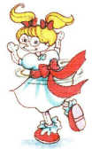 | 2. turn aro_nd | 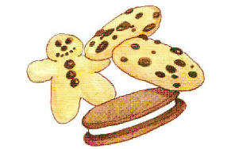 | 3. cook_es
 | 4. cra_on | 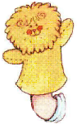 | 5. pu_pet
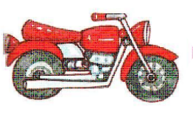 | 6. moto_cycle | 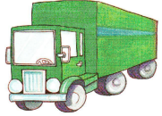 | 7. Tru_k
III. Complete the conversation:
Benny see name’s please too I’m fine
bye like Good Here you thank you’re

Ex: I’m Benny.
Hello, Benny.
1. My________Sue  ________morning, Sue. | 4. Good-_____!  ______ you tomorrow!
2. How are _______?  _______,thank you. | 5. Cookies,_______.  ______ you are.
3. A book._______you.  _________welcome. | 6. I_____pink.  Me,______!

IV. Connect:
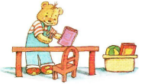 o | o Stand up!
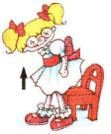 o | o Clean up!
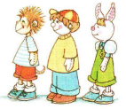 o | o March!
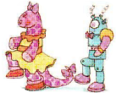 o | o Line up!

V. Which are the same? Circle.
 | 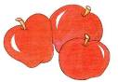

VI. Which is different? Write an X.
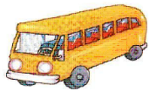

ĐÁP ÁN

I. Look and write:

up  down | juice  apples | a boy  a girl |  | a book  a car
 | Ex: a book |  |  |  | 1.____ down _
 | 2.___ apples __ |  |  |  | 3.____ a boy__
 | 4.___ a car ___ |  |  |  | 5.___ juice___
 | 6._____ a girl ___ |  |  |  | 7.___ up_____
II. Look at the picture and complete the word:
 | Ex: jump |  | 1. pudding
 | 2. turn around |  | 3. cookies
 | 4. crayon |  | 5. puppet
 | 6. motorcycle |  | 7. Truck

III. Complete the conversation:
Benny see name’s please too I’m fine
bye like Good Here you thank you’re

Ex: I’m Benny.
Hello, Benny.
1. My name’s Sue  Good morning, Sue. | 4. Good- bye!  See you tomorrow!
2. How are you?  Fine,thank you. | 5. Cookies, please.  Here you are.
3. A book. thank you.  You’re welcome. | 6. I like pink.  Me, to!
IV. Connect:
o | o Stand up!
o | o Clean up!
o | o March!
o | o Line up!

V. Which are the same? Circle.

VI. Which is different? Write an X.

