ÔN TẬP HỌC KÌ 1 LỚP 2 MÔN TIẾNG ANH
ĐỀ 01
Bài 1: Nối.
planet swim whale clown plane

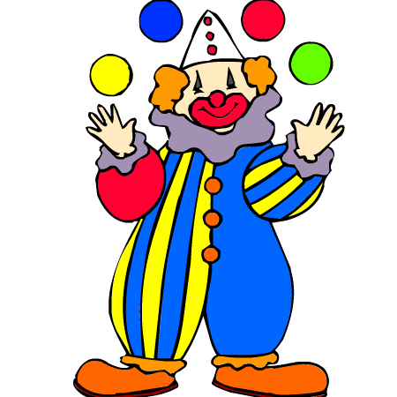


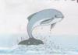
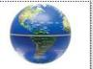

Bài 2: Điền từ phù hợp.
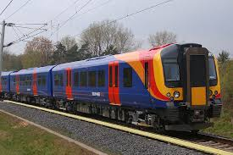
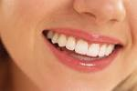

1. ……………… 2. ……………..

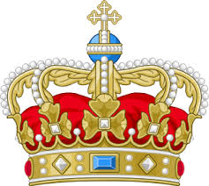
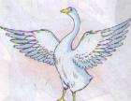

3. …………….. 4. ……………….

Bài 3: Điền chữ cái còn thiếu vào chỗ trống sau:



1. fl_ _er 2. h_ _ se


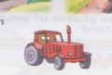
3. _ _actor 4. si _ _

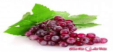
5. g _ apes

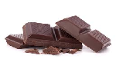
Bài 4: Nhìn tranh viết thành câu hoàn chỉnh:

1. I / chocolate / like /.
………………………………………………….


2 . This / my / is / father / .
…………………………………………………..

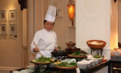
3. My / mother / a good cook / is .
………………………………............................…


4. I / see / can / a / star.
…………………………………….........................…

Bài 5: Chọn từ có cách phát âm khác:
1. rain train star snail
2. ball park hall small
3. swim skip ski skate
4. train tall ball hall
5. chips climb chicken chocolate
ĐỀ 02
I. Điền các cặp chữ cái sau vào đúng vị trí để được từ đúng với tranh. (2đ)
ng cl ch gr
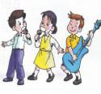 | 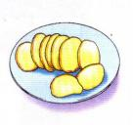 | 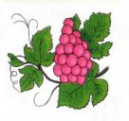 | 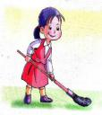
si_ _ | _ _ ips | _ _apes | _ _ ean
II. Nối từ với tranh tương ứng. (3đ)

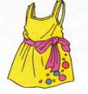 | 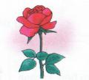 | 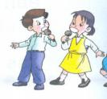
dress house | flower clock | car sing
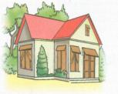 | 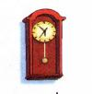 | 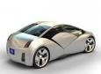

III. Khoanh tròn từ khác loại. (4đ)

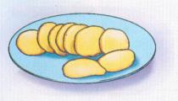 | 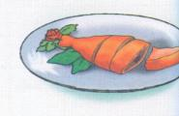 | 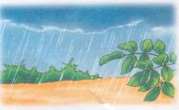
chips | chicken | rain
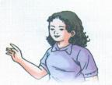 | 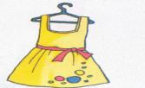 | 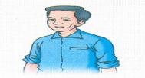
mother | dress | father
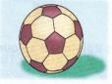 | 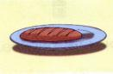 | 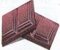
ball | bread | chocolate
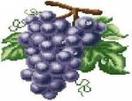 | 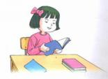 | 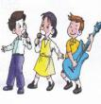
grapes | read | sing

IV. Đọc và hoàn thành các câu sau, dựa vào tranh gợi ý. (1đ)
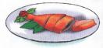  I like _ _ _ _ _ _ _. | 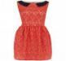  She has a new _ _ _ _ _.
ĐỀ 03
- Read and circle. There is an example.
Example: 0. This is a taxi
A
B
C
D
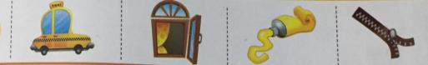

- watermelon
A  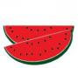 | B   | C   | D  

- Look! A well
A  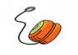 | B  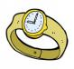 | C  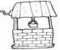 | D  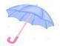
- This is a zebra in the zoo
A  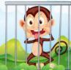 | B   | C  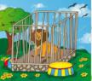 | D  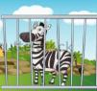
- Where is the van? It’s in the box
A  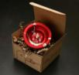 | B  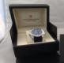 | C  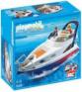 | D  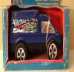
- Re-order the words. There is an example

0. | 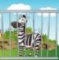  z-a-b-r-e | zebra
1. | 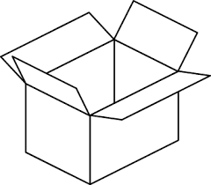  o-b-x | --------------------
2. | 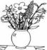  s-a-v-e | --------------------
3. | g-u-r-t-y-o   | --------------------
4. | 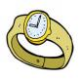  w-a-c-t-h | --------------------

III. Read and match
- sing a. INCLUDEPICTURE "https://s.sachmem.com/public/images/TA2SHS/U11-L1-1-1-b4945579f3861183385a730803adee1c.jpg" \* MERGEFORMATINET 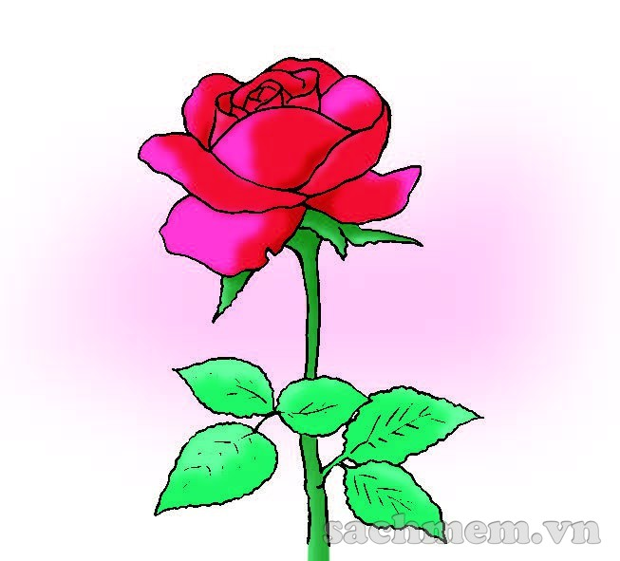

- chicken b. INCLUDEPICTURE "https://s.sachmem.com/public/images/TA2SHS/U1-L1-1-1-d24a6c4d70cc5c8a21bd569e8c9c3e30.jpg" \* MERGEFORMATINET 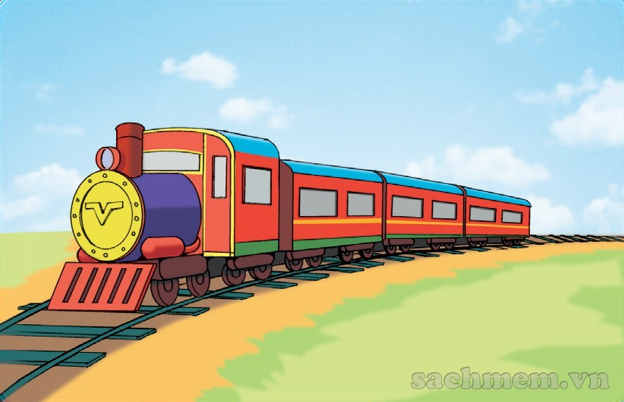
- flower c. INCLUDEPICTURE "https://s.sachmem.com/public/images/TA2SHS/U9-L1-1-1-5fb5e5972ba0e9ed4906a6ad0667a0fc.jpg" \* MERGEFORMATINET 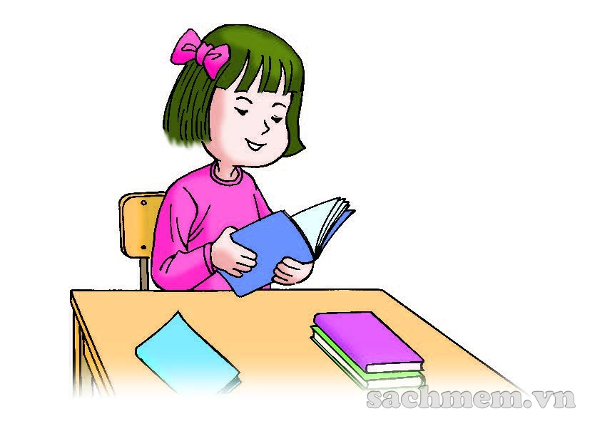
- read d. INCLUDEPICTURE "https://s.sachmem.com/public/images/TA2SHS/U13-L1-1-2-3ce00f50a211d8604df04ab139fe28d1.jpg" \* MERGEFORMATINET 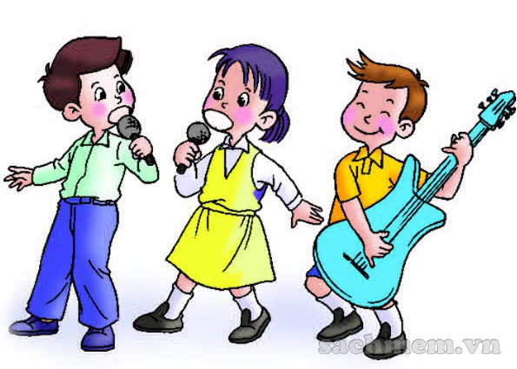
- train e. INCLUDEPICTURE "https://s.sachmem.com/public/images/TA2SHS/U6-L1-1-3-1940a409b036d20ebece3a088fab3edb.jpg" \* MERGEFORMATINET 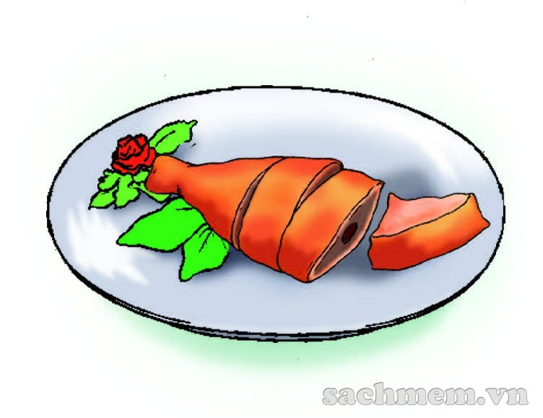
IV. Look and complete
1. _ _ip INCLUDEPICTURE "https://s.sachmem.com/public/images/TA2SHS/U6-L1-1-1-82b5d51182255feae4d0b509a4672811.jpg" \* MERGEFORMATINET 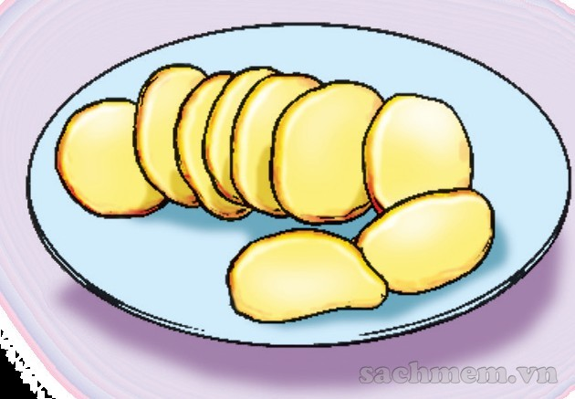

2. B_ _l INCLUDEPICTURE "https://s.sachmem.com/public/images/TA2SHS/U2-L1-1-1-2735beeb714d302ee7590a126c2d01d2.jpg" \* MERGEFORMATINET 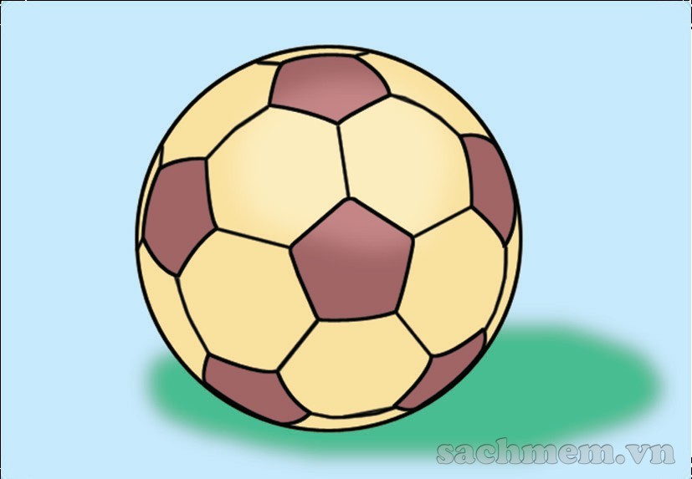
3. t_ _th INCLUDEPICTURE "https://s.sachmem.com/public/images/TA2SHS/U10-L1-1-1-a46fc62d643d092c0a6bea341379bf16.jpg" \* MERGEFORMATINET 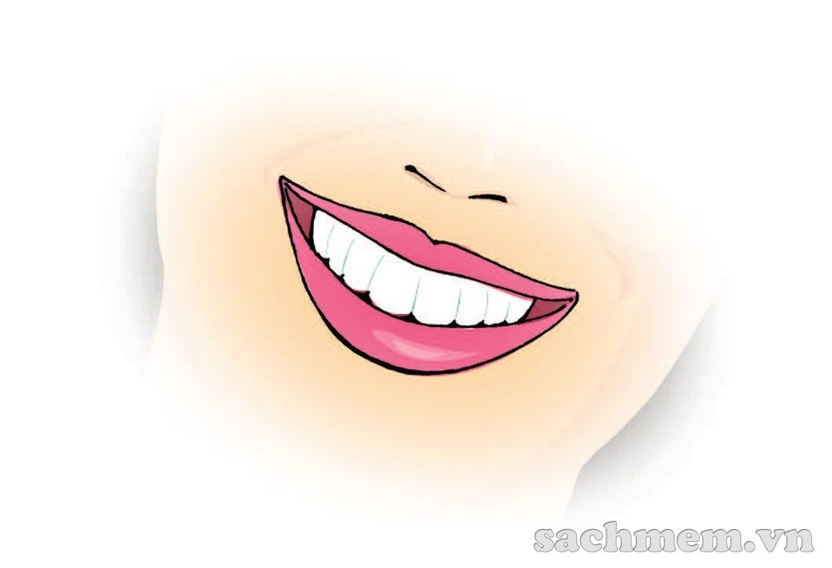
4. _ _apes INCLUDEPICTURE "https://s.sachmem.com/public/images/TA2SHS/U12-L1-1-1-6a5226e0af393cf9b5eedea34449abcd.jpg" \* MERGEFORMATINET 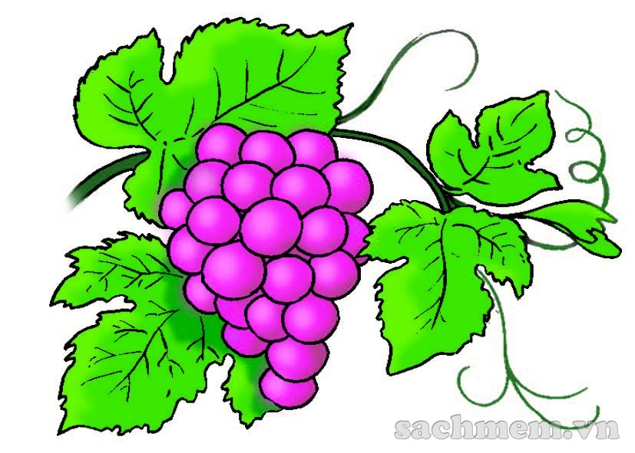
5. C_ _ INCLUDEPICTURE "https://s.sachmem.com/public/images/TA2SHS/U3-L1-1-1-cf2947a620f3f22ca3245204393a1ae2.jpg" \* MERGEFORMATINET 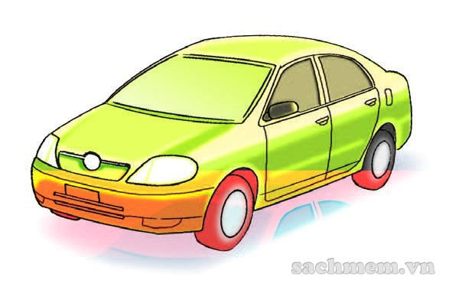

6. _ _ess INCLUDEPICTURE "https://s.sachmem.com/public/images/TA2SHS/U8-L1-1-1-6fa947cee3cfd7b837da976fe71aee0e.jpg" \* MERGEFORMATINET 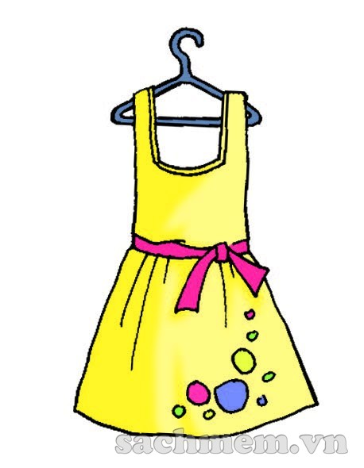
7. _ _other INCLUDEPICTURE "https://s.sachmem.com/public/images/TA2SHS/U5-L1-1-2-058679876b8c2dfaaddfad9ff09a1aa0.jpg" \* MERGEFORMATINET 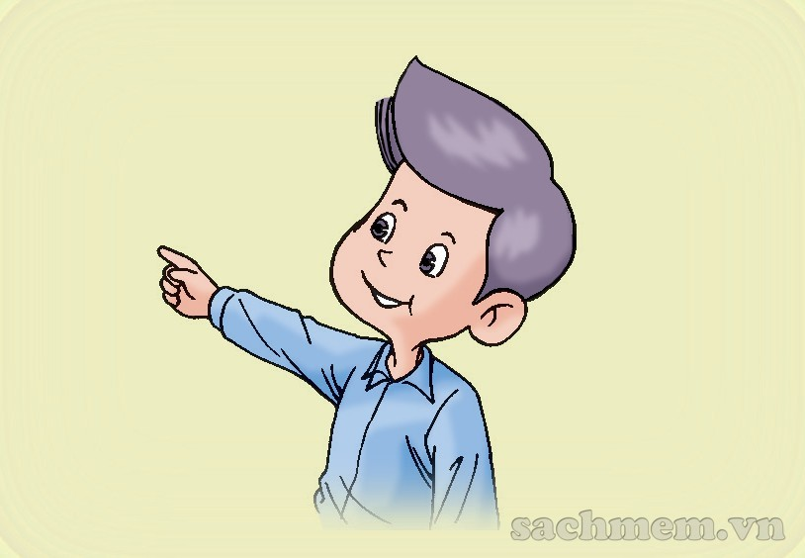
8. _ _ean INCLUDEPICTURE "https://s.sachmem.com/public/images/TA2SHS/U7-L1-1-1-a9078dc69e3345cec912d659dd6fbff8.jpg" \* MERGEFORMATINET 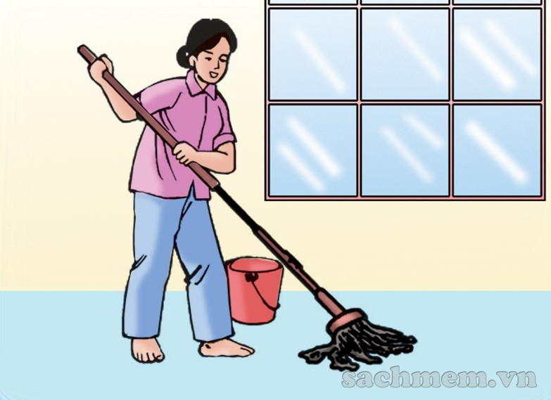
ĐỀ 04
- Question and short answer:
Is it a/an………..?  Yes, it is. | Is it a/an………..?  No, it isn’t.

Note: an + danh từ số ít bắt đầu bằng 1 trong các nguyên âm u, e, o, a, i
1/ Match the question with the responses
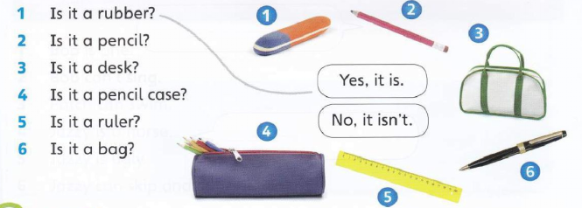II. Match the questions with the responses. 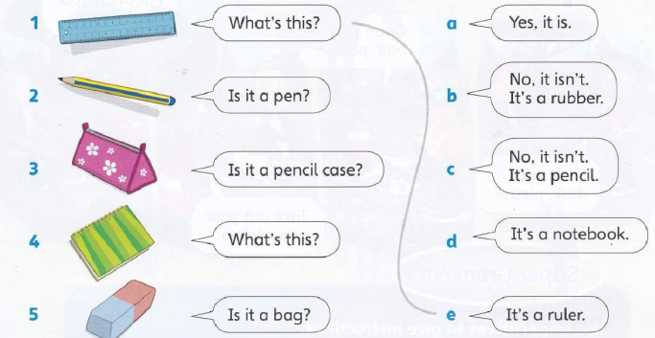
III. Complete the sentence
a/ Is it an orange?  Yes, it is. | 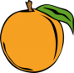
b/ Is it a ruler?  …………………….. | 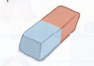
c/ Is it a pencil case?  …………………………… | 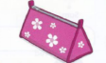
d/ ………………………  Yes, it is. | 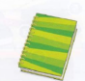

IV. Rearrange the words to make a sentence.
Example: a/ this/ What/ is/? → What is this?
A/ pen /is/ This. → This is a pen.
b/ is/ that/ What/? →………………………………………….
is/ that/ a/ ruler/. →…………………………………………
c/ it/ Is/ pencil case/ a/? →……………………………………….
Yes/ is/ it. →…………………………………………………….
d/ book/ Is/ it/ a? →………………………………………………
isn’t/ No/ it. →……………………………………………….
e/ Is/ this/ rubber/ a? →……………………………………………….
No/ isn’t/ it. →……………………………………………….
f/ this/ Is/ an/ umbrella? →……………………………………………….
is/ it/ Yes. →……………………………………………….

