ĐỀ KIỂM TRA HỌC KÌ 1 TIẾNG ANH LỚP 3
CÓ ĐÁP ÁN NĂM 2020 - 2021

Đề thi học kì 1 tiếng Anh lớp 3 có file nghe, đáp án - Đề số 1
Read and circle the correct words.
1. Are those your (ruler/ rulers)?
2. Do you like hide-and-seek? - No, I (do/ don't).
3. May I (go/ come) out?
4. What color (is/ are) your pencil?
Fill the blanks.
May/ Yes/ color/ It's/
5. ______ I come in?
6. _____, you can.
7. What ________ is your book?
8. ______ blue.
Underline the mistake and fix it.
9. What color are your pencil cases? - It's green.
10. May I go out? - No, I can.
11. Do Lan like skating?
12. Are this your pencils?
Listen and write.
Bài nghe
Ex: Hello, class.
13. __________________________
14. __________________________
15. __________________________
16. __________________________
Read and match.
17. Is this Linda? | A. P-H-O-N-G.
18. Are they your friends? | B. Yes, it is.
19. How do you spell your name? | C. This is Mr. Loc.
20. Who's that? | D. No, they aren't.
ĐÁP ÁN
Read and circle the correct words.
1 - rulers; 2 - don't; 3 - go; 4 - is;
Fill the blanks.
5. ____May__ I come in?
6. ___Yes__, you can.
7. What ___color_____ is your book?
8. ___It's___ blue.
Underline the mistake and fix it.
9 - It's thành They are/ They're.
10 - No thành Yes hoặc can thành can't;
11 - Do thành Does;
12 - this thành these;
Listen and write.
13 - How you do spell your name?
14 - What do you do at break time?
15 - I play hide-and-seek.
16 - These are my rubbers.
Read and match.
17 - B; 18 - D; 19 - A; 20 - C;

Đề thi tiếng Anh lớp 3 học kì 1 có file nghe + ma trận - Đề số 2
I. MA TRẬN
Kỹ năng | Nhiệm vụ đánh giá/ kiến thức cần đánh giá | Mức/ điểm |  |  |  | Tổng số câu , số điểm, tỉ lệ %
 |  | M1 | M2 | M3 | M4
Listening  5pts =50% | 1. Listen and circle |  | 0,5đ  (2 câu) | 0,5đ  (2 câu) |  | 4 câu = 1 điểm
 | 2. Listen and tick | 0,25đ  (1câu) | 0,5đ  (2 câu) | 0,25đ  (1câu) |  | 4 câu = 1 điểm
 | 3. Listen and number | 1đ  (4 câu) |  |  |  | 4 câu = 1 điểm
 | 4. Listen and complete | 0,5đ  (2 câu) |  | 0,25đ  (1 câu) | 0,25đ  (1 câu) | 4 câu = 1 điểm
Reading  1,5pts = 15% | 5. Read and tick (v) or (x) |  | 0, 5đ  (2 câu) | 0,25đ  (1 câu) | 0,25đ  (1 câu) | 4 câu = 1 điểm
 | 6. Read and write Yes/No |  | 0,5đ  (2 câu) | 0,25đ  (1 câu) | 0,25đ  (1 câu) | 4 câu = 1 điểm
Writing  1,5pts = 15% | 7. Look and write the words in order. |  | 0,5đ  (2 câu) | 0,5đ  (2 câu) |  | 4 câu = 1 điểm
 | 8. Fill in the gaps |  |  | 0,5đ  (2 câu) | 0,5đ  (2 câu) | 4 câu = 1 điểm
Speaking  2pt = 20% | -Respond the questions of teacher. | 1đ  (4 câu) |  |  |  | 8 câu= 2 điểm
 | -Discribe the pictures in sts’ book by answering questions of teacher. | 0,5đ  (2 câu) | 0,5đ  (2 câu)
Tổng số câu |  |  |  |  |  | 40 câu

II. NỘI DUNG ĐỀ THI
PART I. LISTENING (5pts)
1. Listen and circle (1pt)
0. Girl: May I __________, Miss Hien?
Miss Hien: No, you can’t.
a. sit down b. go out c. come in
1. Miss Hien: Good morning class!
Class: Good morning Miss Hien!
Miss Hien: ___________, please!
a. Stand up b. Sit down c. Come in
2. Miss Hien: _________!
Boy: Sorry Miss Hien.
a. Be quiet b. Stand up c. Good morning
3. Class: Goodbye Miss Hien!
Miss Hien: ________ class.
a. don’t talk b. come here c. goodbye
4. Mai: May I _______?
Miss Hien: Yes, you can
a. go out b. come here c. come in

2. Listen and tick (1pt)
c

b
a
1.

c
b
a
2.
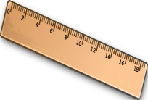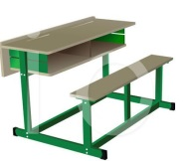

c
b

a
3.
b

c
4.
a

3. Listen and number. (1pt)
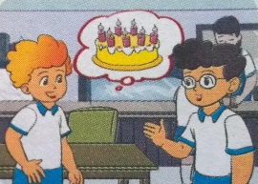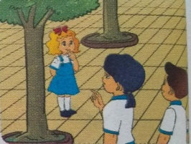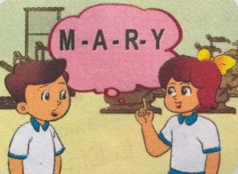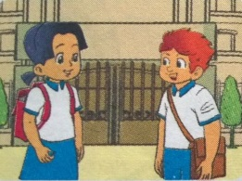

d
c
b
a

4. Listen and complete (1pt)
0. I’m eight years old.
- Is ………your friend?
- These are my ………
- My pen is………
- The school ………..is large.
PART II. READING AND WRITING (4pts)
 | 1.That is the gym.
 | 2. May I come in ?
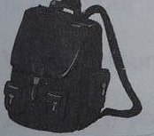 | 3. This is my school bag.
 | 4. This is a pencil.
6. Look and read. Put a tick ( ) or cross (X ) in the box. (1pt)

7: Look and read. Write Yes or No. (1pt)
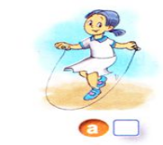 | 0. skating | ______ | 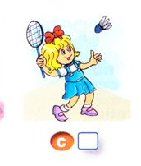 | 2. badminton | _______
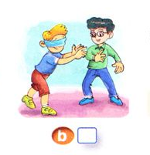 | 1. hide- and- seek. | ______ | 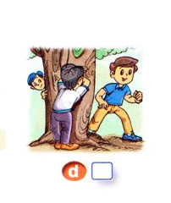 | 3. blind man’s bluff | _______

8: Look at the pictures. Write the words. (1pt)
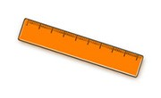 | - Lrure → | R_ _ _ _
 | 1. Tobfolal → | f_ _ _ _ _
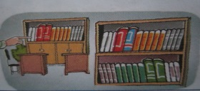 | 2. Irybral → | l_ _ _ _ _
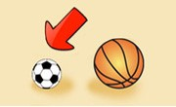 | 3. Mslla → | s_ _ _ _ _

9: Fill in each gap with a suitable word from the box (1 pt)

School things pens Those notebook

There are some (1)…………………… on my desk. This is my school bag. It is yellow. That is my (2)…………….. It’s blue. These are my (3)…………… They are black. (4)……………. are my pencils. They are orange. What color are your pencils?
PART III. SPEAKING (2pt)
- Interview.
Ask about personal information (name, age, break time activities, ability)
2. Identifying objects.
What’s this/ What’s that/ What are these/ What are those?
What color is it? What color are they?
3.Describing the picture.
ĐÁP ÁN
Q | Answer | point | total
1 | 1-b 2-a 3-c 5-c | 0,25/ each | 1 pt
2 | 1- b 2- a 3- b 4-c | 0,25/ each | 1 pt
3 | 1-c 2-d 3-a 4-b | 0,25/ each | 1 pt
4 | 1. that 2. Books 3. Blue 4. Playground | 0,25/ each | 1 pt
5 | 1. X 2.V 3. V 4. x | 0,25/ each | 1 pt
6 | 1. No 2. Yes 3. No 4. No | 0,25/ each | 1 pt
7 | 1. ruler 2. Football 3. library 4. small | 0,25/ each | 1 pt
8 | 1. school things 2. Notebook 3. Pens 4. Those | 0,25/ each | 1 pt
9,10 | Speaking test | 0,25/ each | 2 pts
Transcript
1. Listen and circle: (1pt)
1. Miss Hien: Good morning class!
Class: Good morning Miss Hien!
Miss Hien: sit down, please!
2. Miss Hien: be quiet!
Boy: Sorry Miss Hien.
3. Class: Goodbye Miss Hien!
Miss Hien: goodbye class.
4. Mai: May I come in?
Miss Hien: Yes, you can
2. Listen and tick: (1pt)
1. This is my penbox. It is old.
2. This is my pencil sharpener. It is red.
3. That is my ruler. It is big.
4. These are my pens. They are new.
3. Listen and number. (1pt)
1. How old are you, Peter?
I’m seven years old.
2. What’s your name?
My name’s Mary.
How do you spell Mary?
That’s M-A-R-Y
3. Who’s that?
It’s my friend, Linda.
4. Hello, Mai. How are you?
Hi, Tony. I’m fine, thank you. And you?
I’m fine. thanks
4. Listen and complete. (1pt)
1. Is that your friend?
2. These are my books
3. My pen is blue
4. The school playground is large.

