ĐỀ THI HỌC KÌ 1 LỚP 4 NĂM HỌC 2017 - 2018
MÔN TIẾNG ANH
Question 1. Listen and tick
1.
- b. c.

2.
- . b. c.

3.
- b. c.

Question 2. Listen and number
a.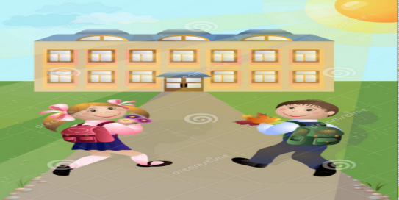b. 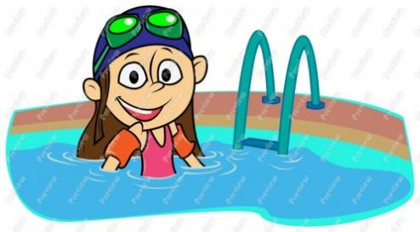
c. 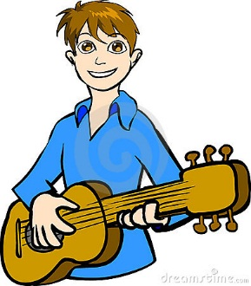d.
Question 3: Listen and match
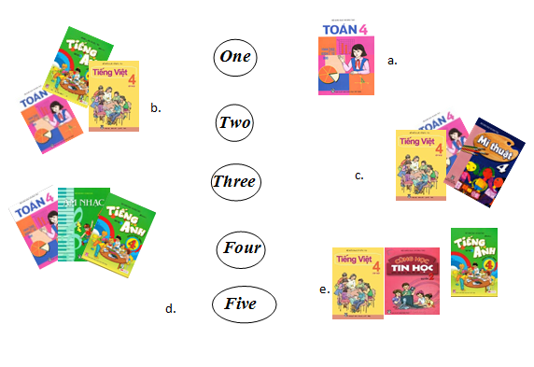 Question 4: Listen and circle. (1 pt)
1. a. I’m very well. b. I’m fine. c. I’m well.
2. a. English b. Japanese c. Vietnamese
3. a. Monday b. Tuesday c. Sunday
4. a. Nguyen Trai Street b. Nguyen Hue Street c. Nguyen Du Street
5. a. reading b. swimming c. cooking
Question 5: Listen and complete (1pt)
Peter: What (1) ___ is it today, Tom?
Tom: It’s Monday
Peter: Do you have (2) ________ today?
Tom: Yes, I do.
Peter: What (3) ________ do you have today?
Tom: I have Vietnamese, Maths and (4) ________.
Peter: Oh, we’re (5) ________ for school!
Tom: Let’s run
Part II/ Reading and Writing (15 minutes)
Question 6: Read and complete (1pt)
My name is Nga. I go to school from Monday to Friday. I have Vietnamese and Maths every day. I have English on Mondays, Tuesdays, Thursdays and Fridays. On Wednesdays and Thursdays, I have Science. I have PE on Mondays and Wednesdays. I have Music on Tuesdays and Art on Friday.

Monday | Tuesday | Wednesday | Thursday | Friday
 |  | Vietnamese | Vietnamese
Maths | Maths |  |  | Maths
English |  | Science | English
 | Music |  |  | English
Question 8: Look at the pictures and the letters. Write the right words(1 pt)
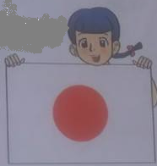
- She is from J_ _ _ _
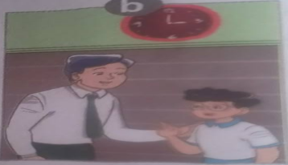
- Good _ _ _ _ _ __ _ _
- She can _ _ _ _
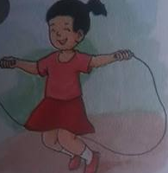
- She like _ _ _ _
Question 8: Look and read. Put a tick (√) or cross (X) in the box(1pt)
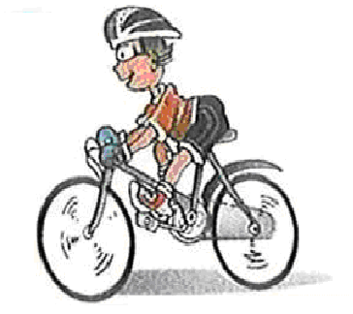He can dancing
It’s on the sixteen of October

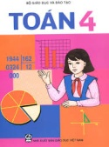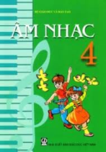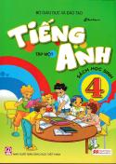 I have Maths, Vietnamese and Music

I am from England
Question 9: Reorder the words(1pt)
- is/ birthday/ when/ your
_____________________________________
- what/ doing/ she/ is
_____________________________________
- subjects/ do/ have/ what/ today/ you
_____________________________________
- I/ Australia/ from/ am
_____________________________________
- / piano/ I/ played/ the/ yesterday
_____________________________________
- are/ you/ where/ from
_____________________________________
- / am/ play/ guitar/ I/ the
_____________________________________
- meet/ to/ you/ nice
_____________________________________
- swim/ you/ can
_____________________________________
- class/ 4B/ am/ I/ in
_____________________________________

