ĐỀ THI HỌC KÌ 2 TIẾNG ANH LỚP 4
CÓ ĐÁP ÁN NĂM 2019 - 2020
I. LISTENING
Task 1. Listen and tick . There is one example.
Example:
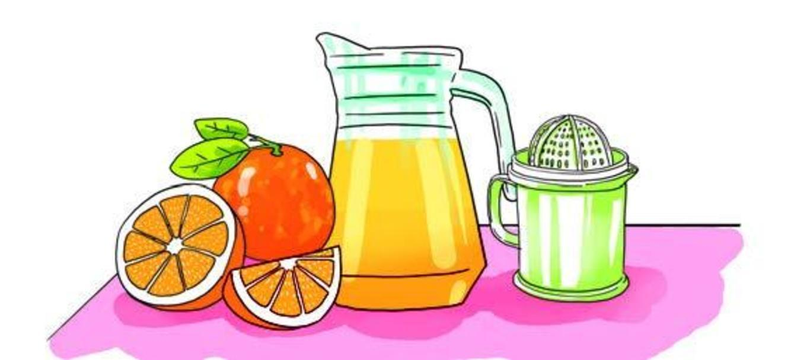  A. |   B. 

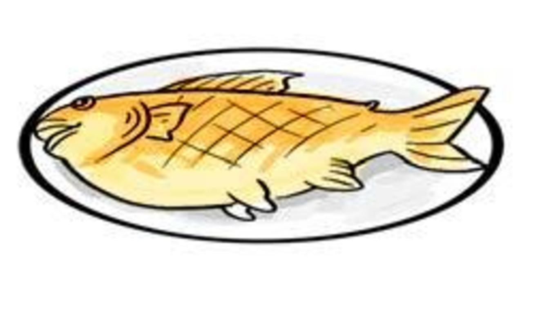  1. A. | 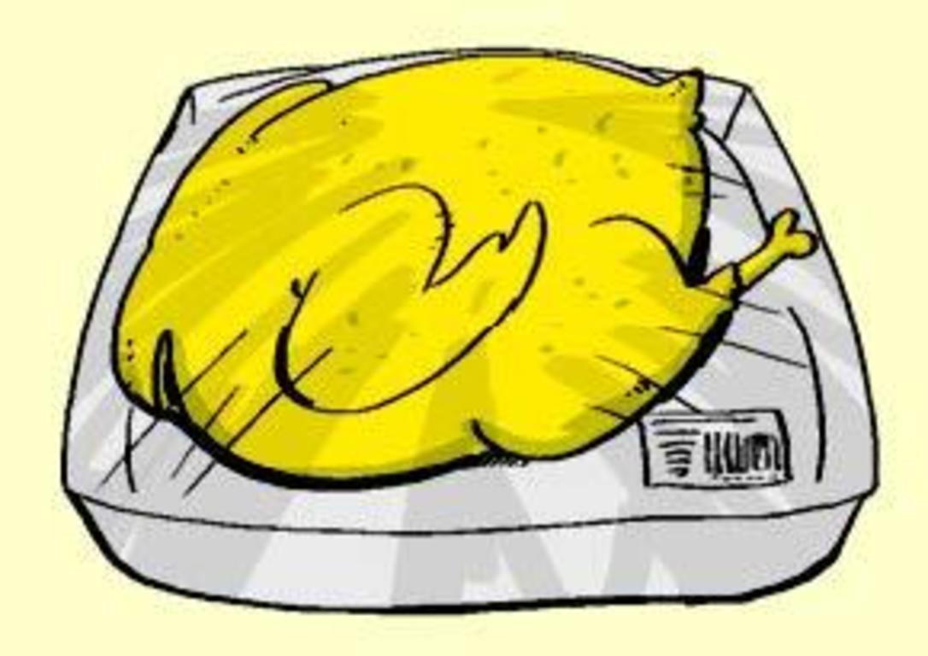  B.
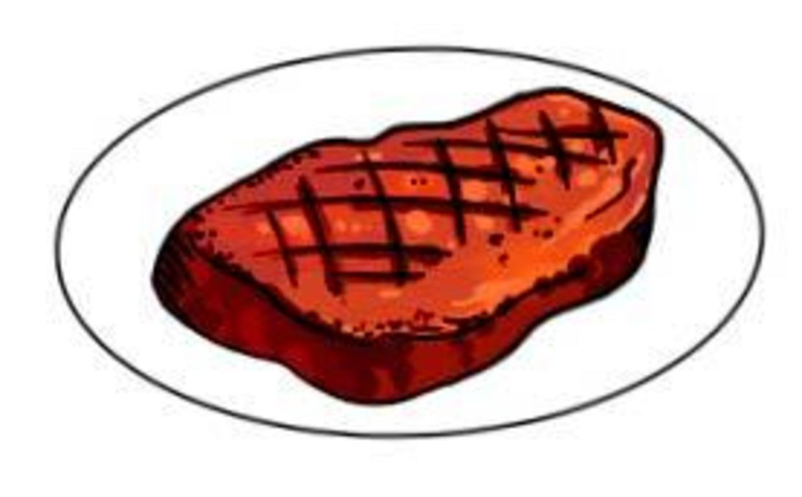  2. A. | 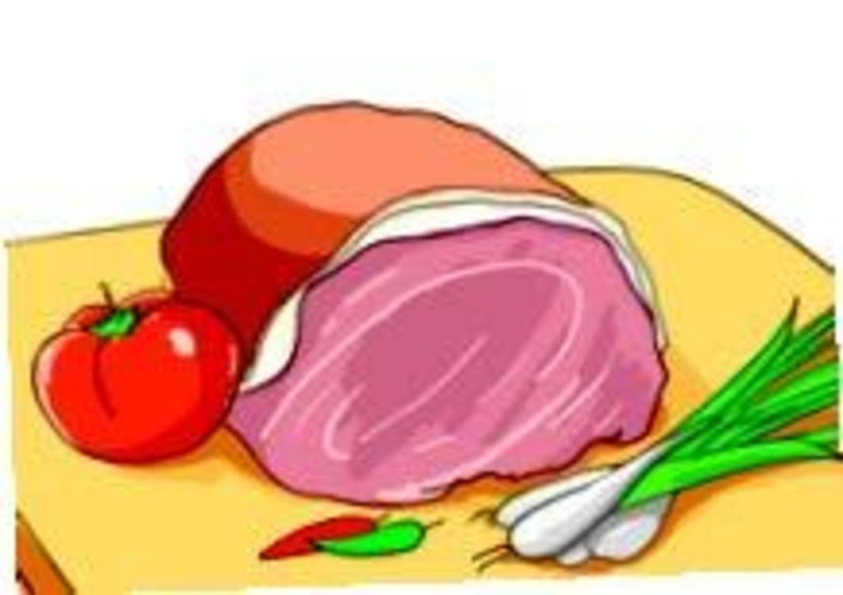  B.
  3. A. | 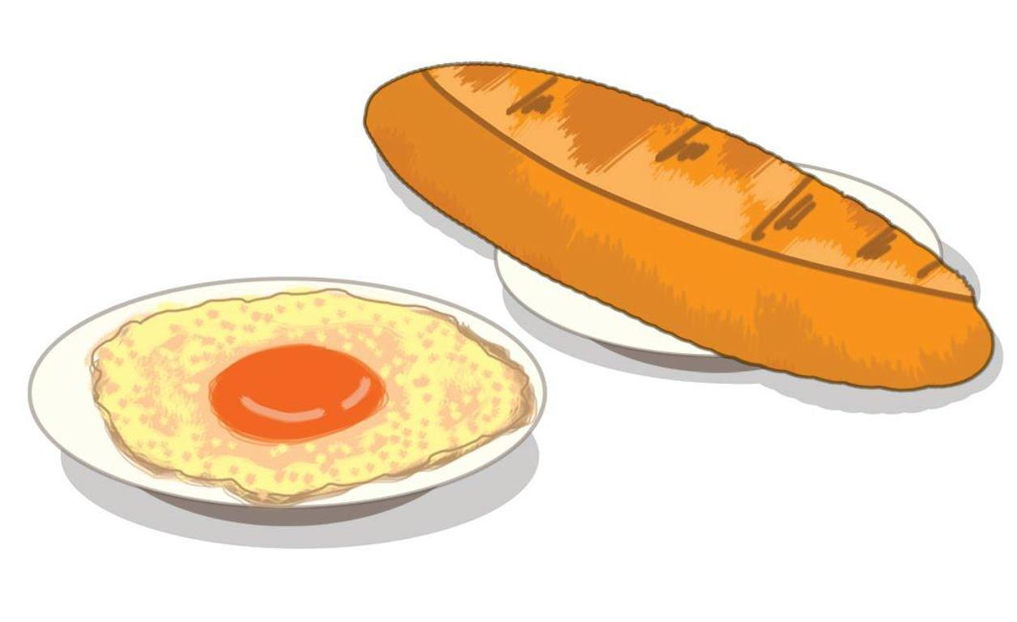  B.
  4. A. |   B.
5. A. | 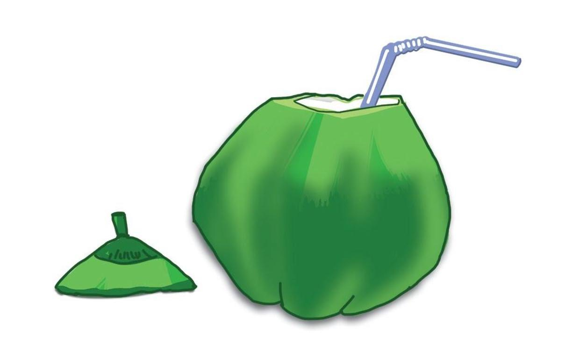  B.
Task 2. Listen and tick or cross . There are two examples.
Examples:
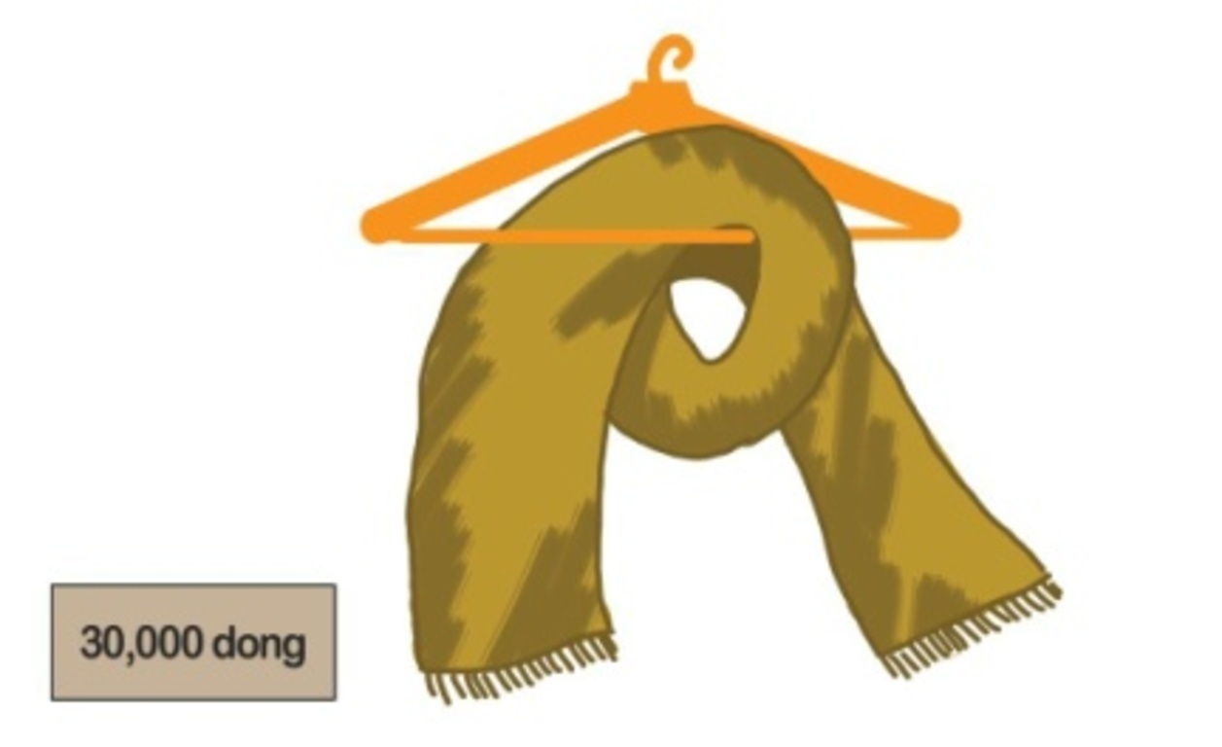  A. | 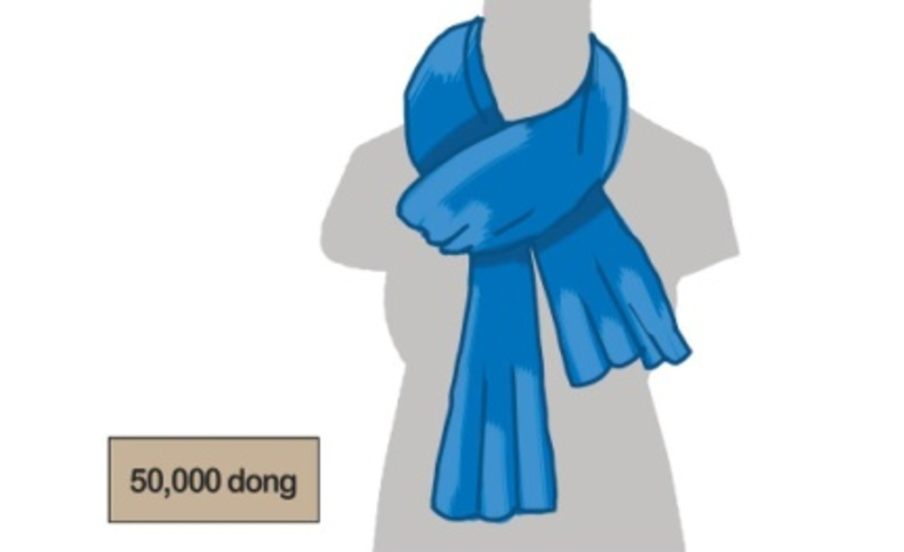  B.

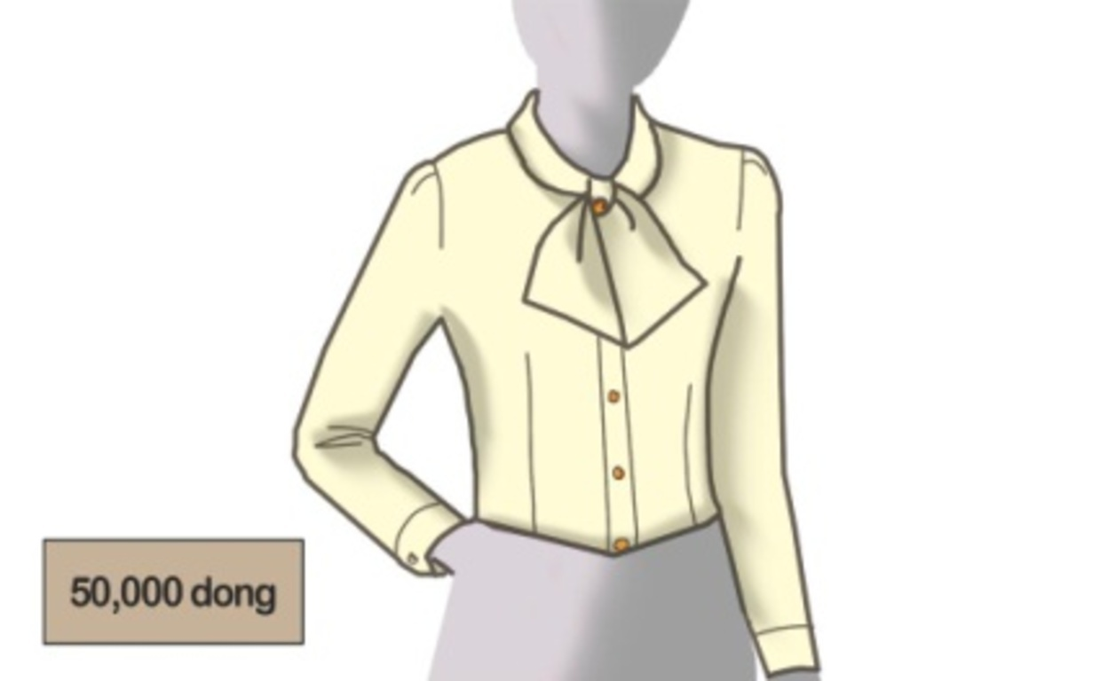  1. | 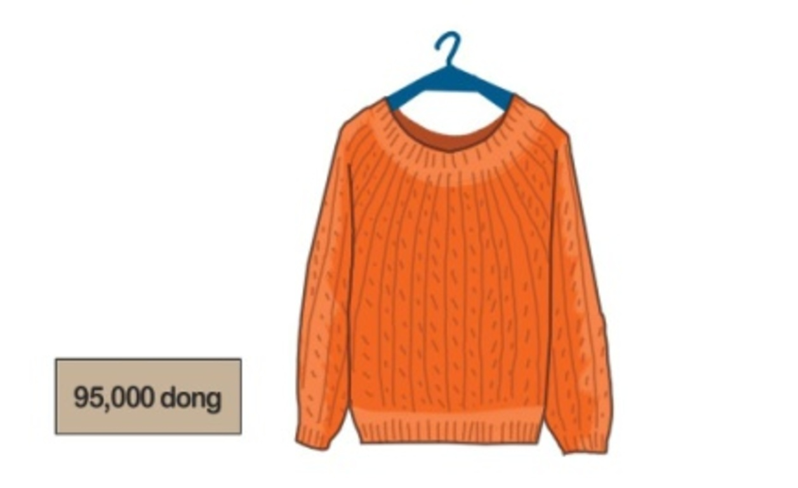  2. | 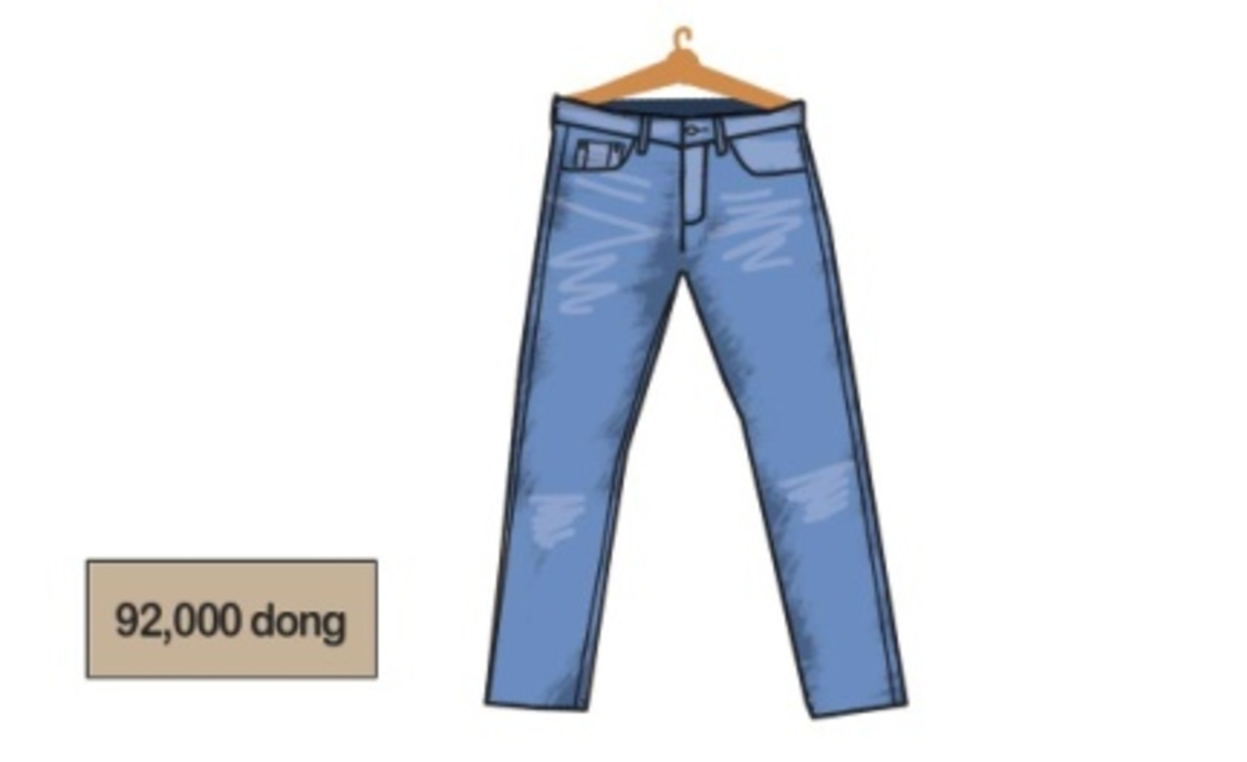  3.
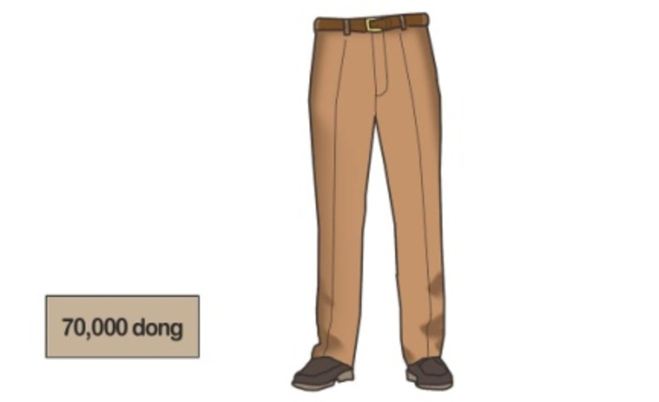  4. | 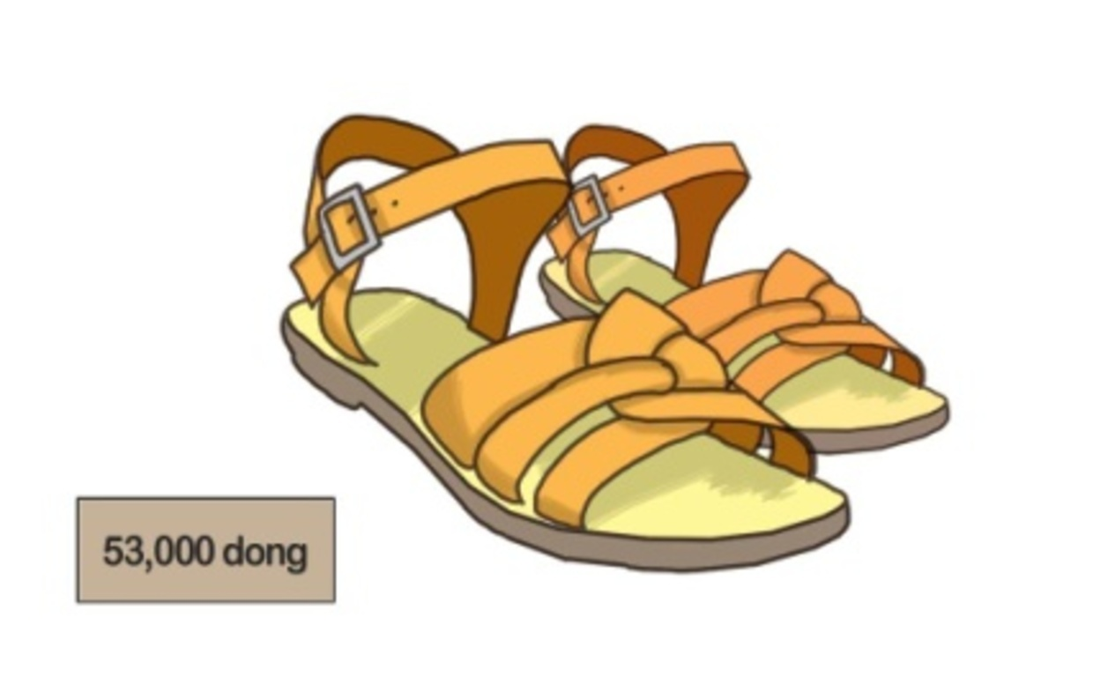  5.
Task 3. Listen and draw lines. There is one example (0).

A.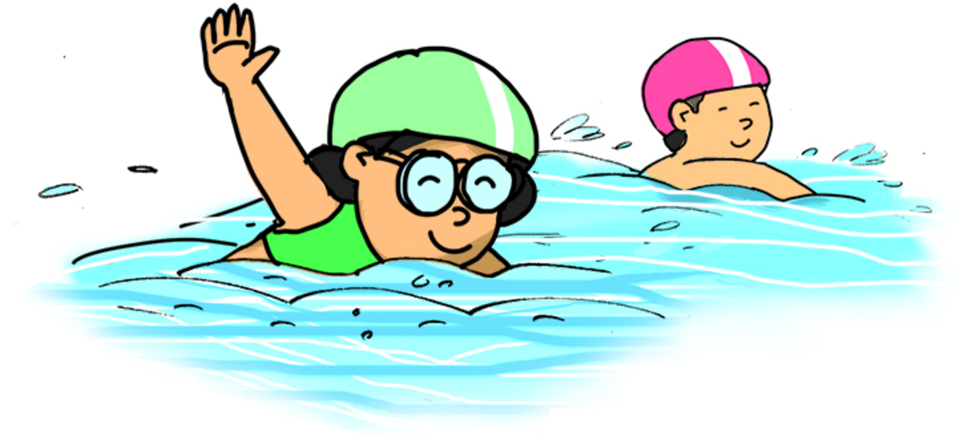 | B.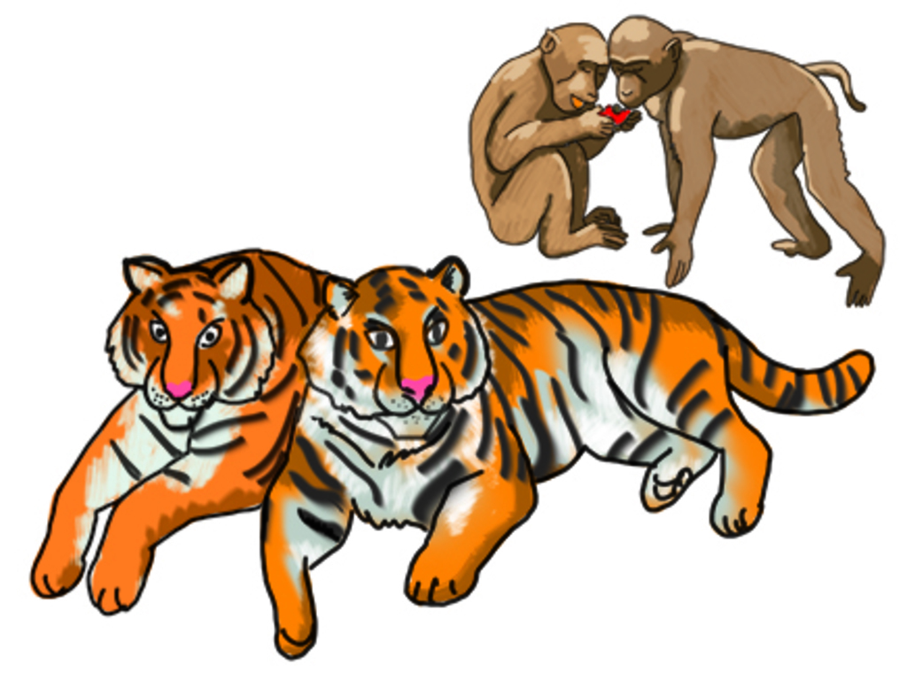 |  | C.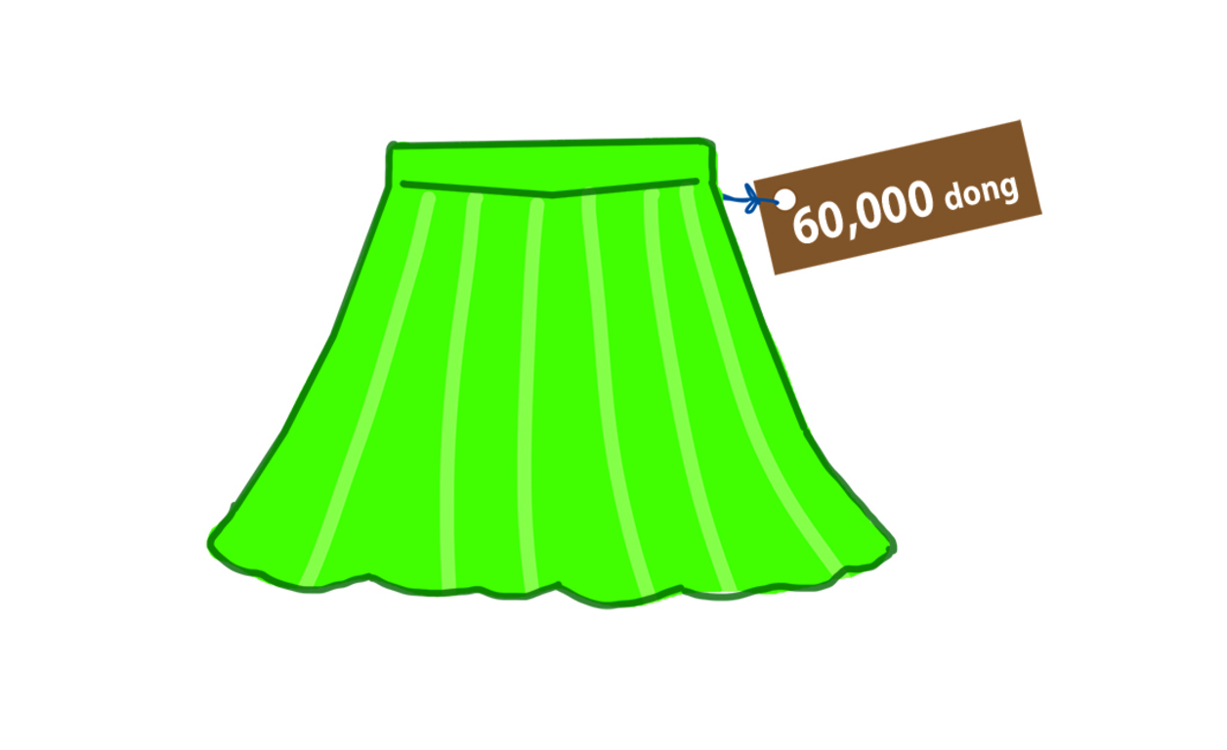
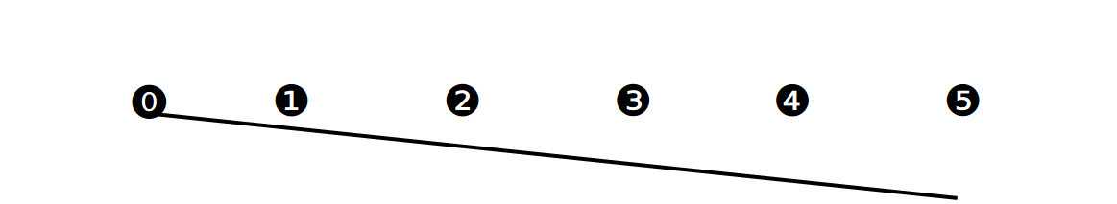
D. |  | E.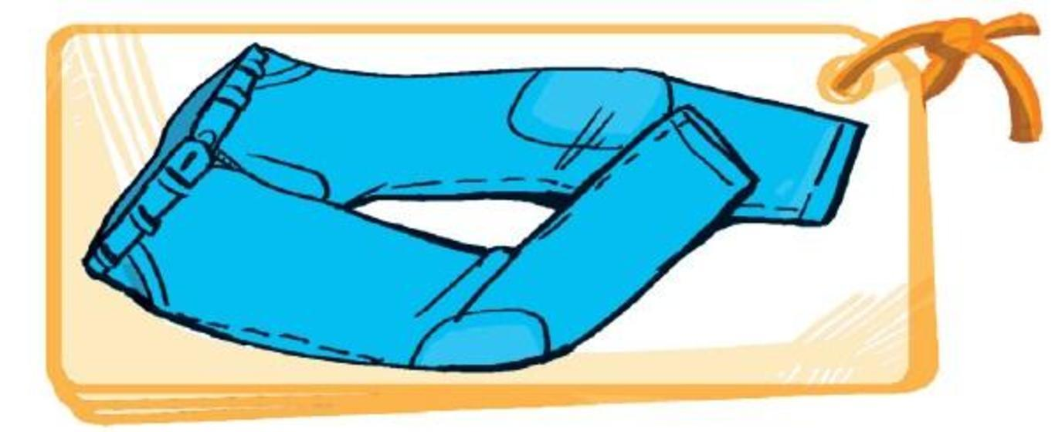 |  | F.
II. READING AND WRITING
Task 1A. Read and tick or cross . There are two examples.
Examples:
  1. My phone number’s 0912 283 3804. |   B. I’d like to go skating.

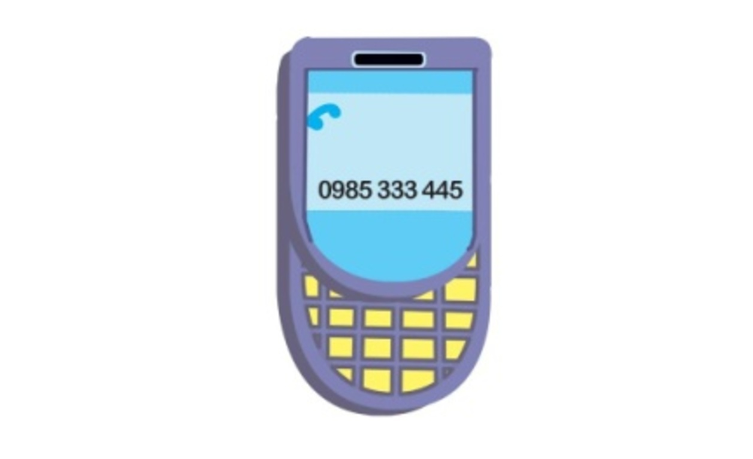  1. David’s phone number’s 0985 333 445. |   2. Janny’s phone number’s 0912 238 855.
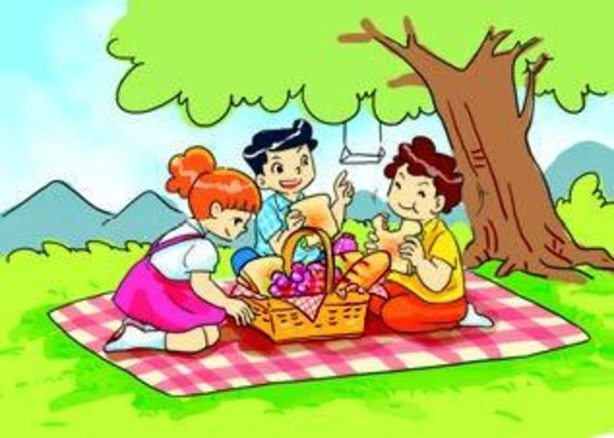  3. I’d like to go for a picnic. |   4. She wants to go for a walk.
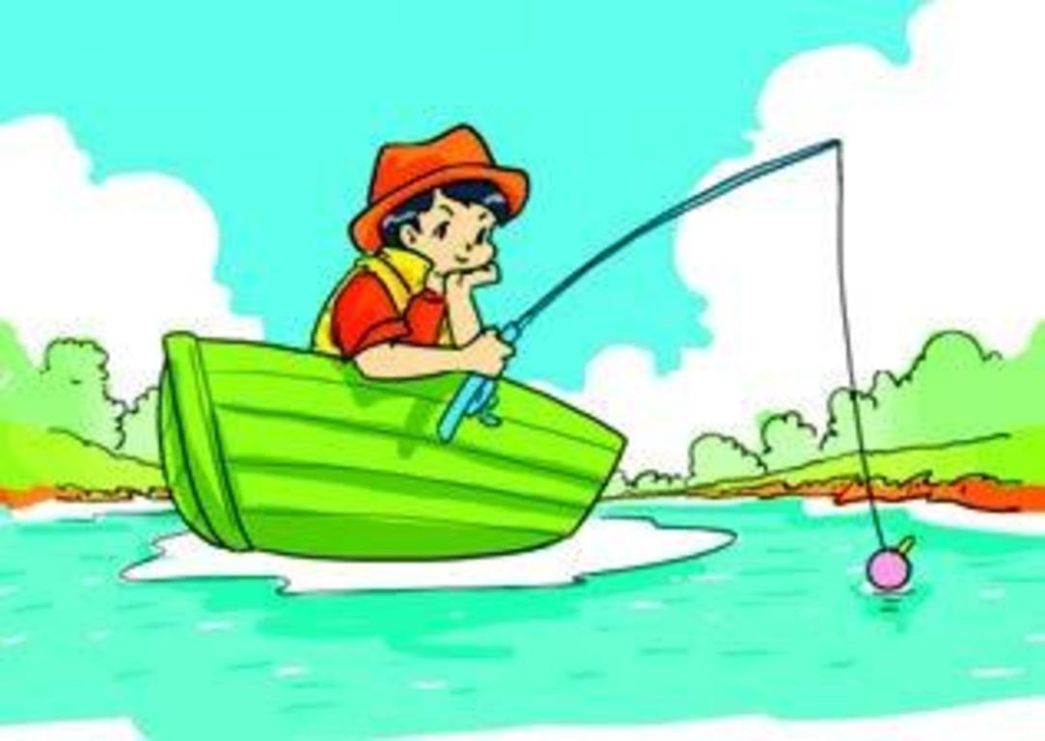
5. He wants to go fishing.
Task 2. Order the words. There is one example.
Example: kangaroos/like/I/much/very
I like kangaroos very much.
1. you/what/animal/want/to/do/see
___________________________________________?
2. to/he/tigers/see/wants/bears/and
___________________________________________.
3. like/fruit/eating/monkeys
___________________________________________.
4. they/because/she/zebras/likes/beautiful/are
___________________________________________.
5. animal/what’s/favourite/your
___________________________________________?
Task 3. Read and write YES or NO. There is one example (0).
Hi, my name is Quan. I wear different kinds of clothes for schooldays. On hot days at school, I often wear a cap, a T-shirt, a pair of shorts, a red scarf and a pair of sandals. On cold days, I usually wear a cap, a jacket over a jumper, a pair of trousers, a red scarf, a pair of socks and shoes. I like hot days because I can wear light clothes to school.
0. Quan wears different kinds of clothes for schooldays. | YES
1. He wears wear a cap, a T-shirt, a pair of shorts on hot days. | ______
2. He also wears a pair of socks and shoes on hot days. | ______
3. He wears a jacket over a jumper, a pair of trousers on cold days. | ______
4. He usually wears a pair of sandals on cold days, too. | ______
5. He likes hot days because he can wear light clothes at home. | ______
ĐÁP ÁN
I. LISTENING
Task 1. Listen and tick . There is one example.
Key: 1. A 2. A 3. B 4. B 5. A
Task 2. Listen and tick or cross . There are two examples.
Key: 1. 2. 3. 4. 5.
Task 3. isten and draw lines. There is one example (0).
Key: 1. C 2. E 3. D 4. B 5. A
II. READING AND WRITING
Task 1A. Read and tick or cross . There are two examples.
Key: 1. 2. 3. 4. 5.
Task 2. Order the words. There is one example.
Key:
1. What animal do you want to see?
- He wants to see tigers and bears.
- Monkeys like eating fruit.
- She likes zebras because they are beautiful.
5. What’s your favourite animal?
Task 3. Read and write YES or NO. There is one example (0).
Key: 1. YES 2. NO 3. YES 4. NO 5. NO

